Unit Testing:

Unit Testing was added for the user repository and transaction repository.

User Repository:

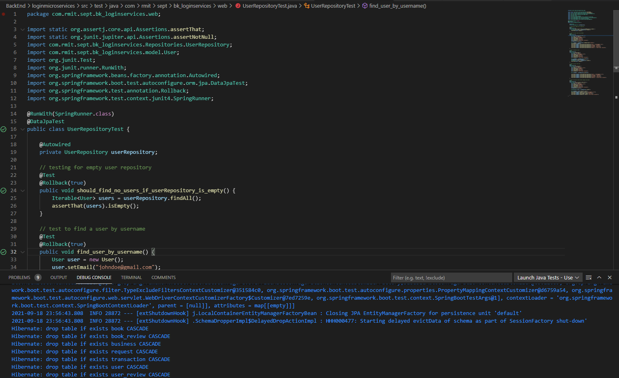

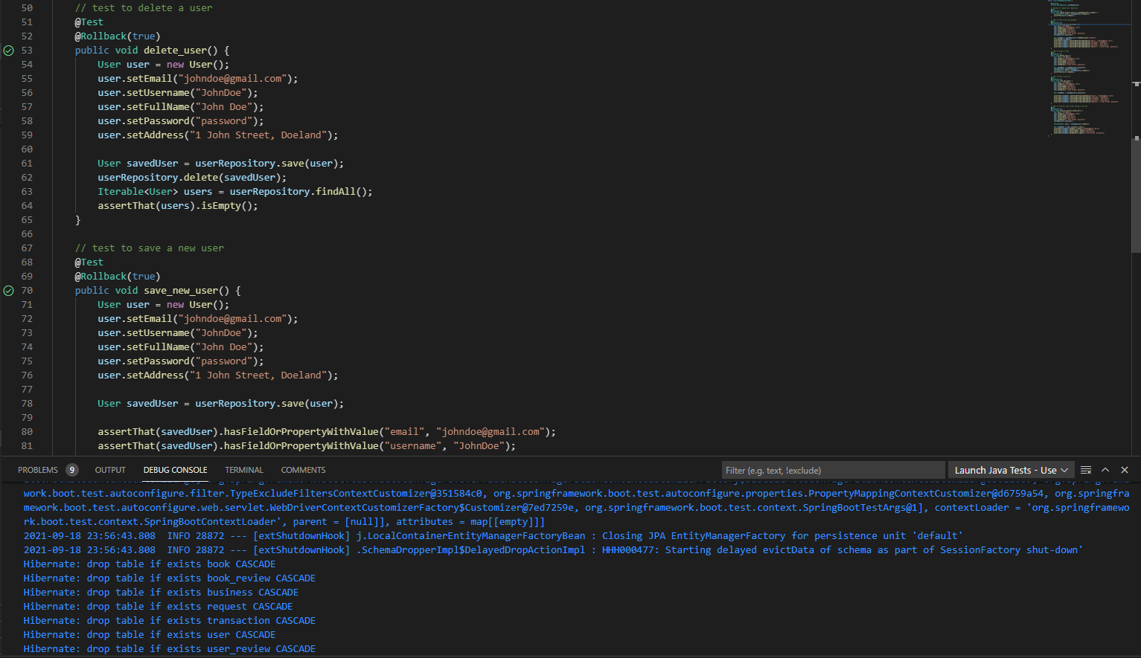

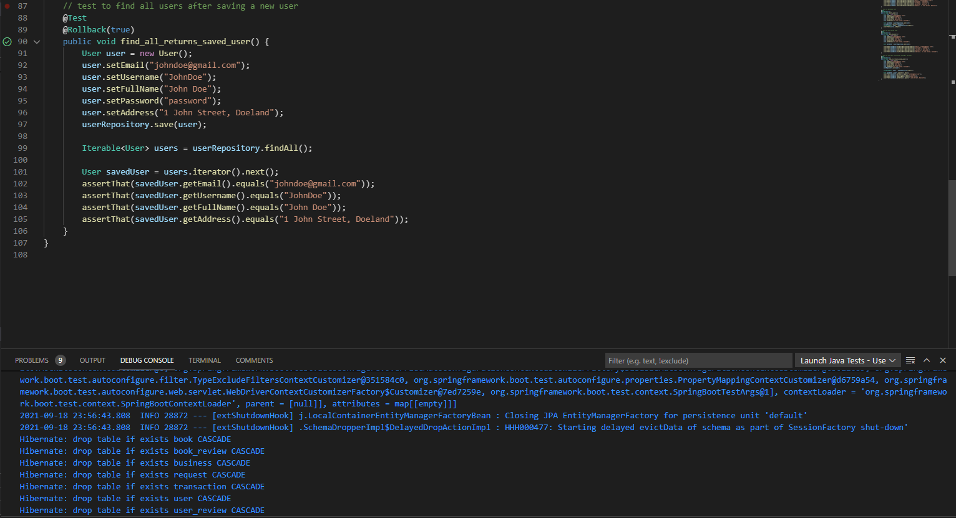

Transaction Repository:

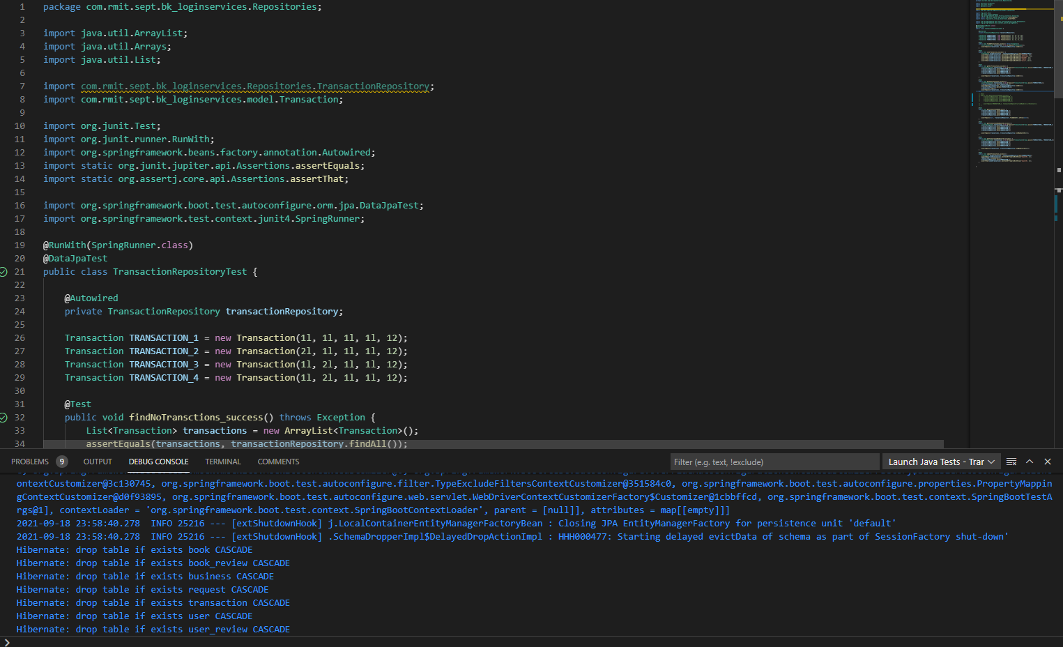

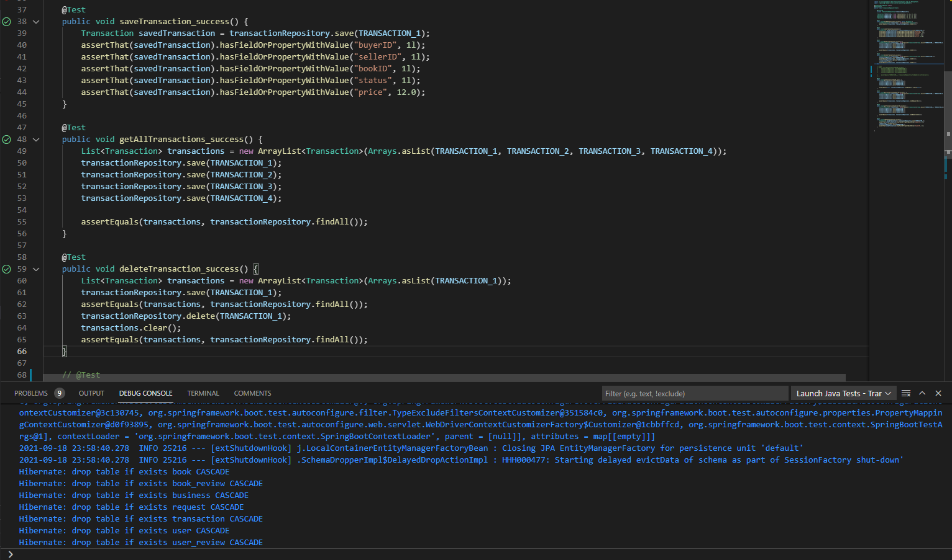

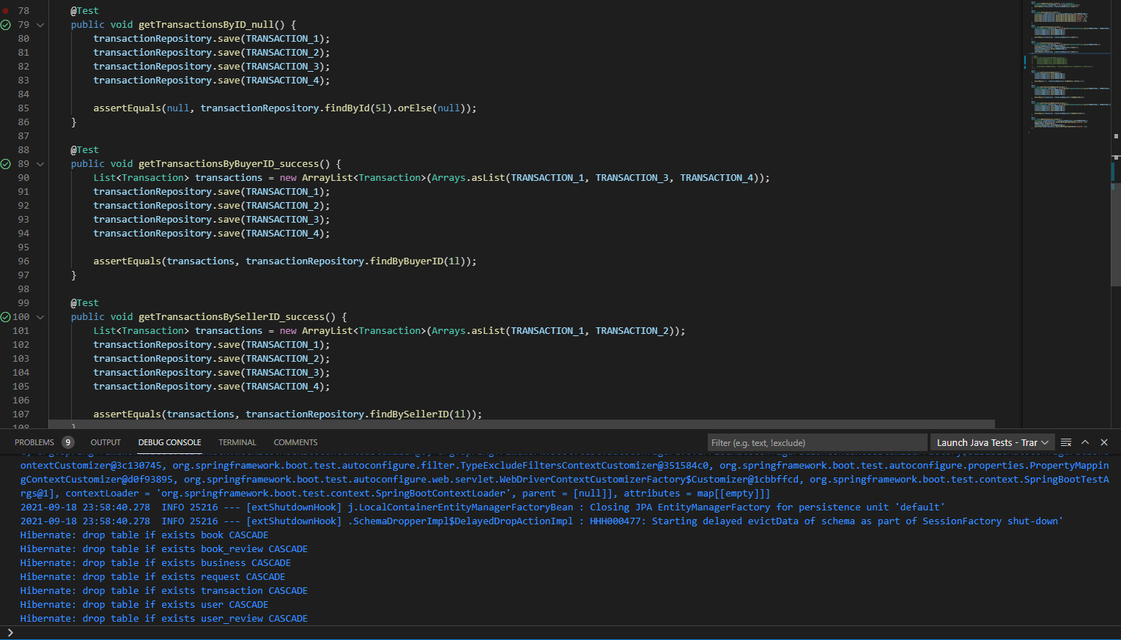

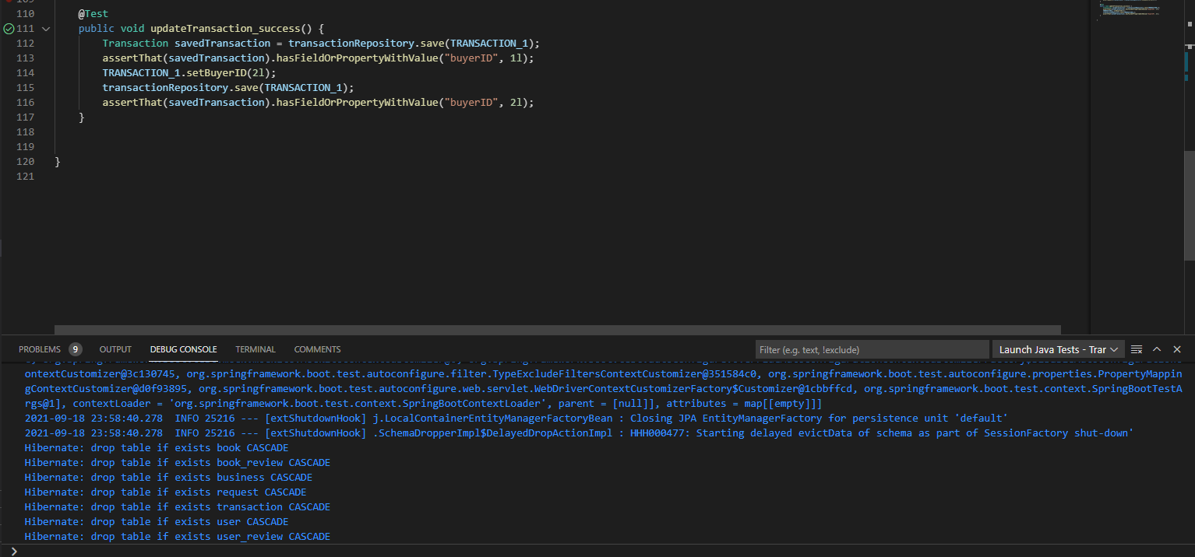

Acceptance Testing:

# As an Admin, I want to login to my admin account so that I can access my admin profile.

Admin login page:

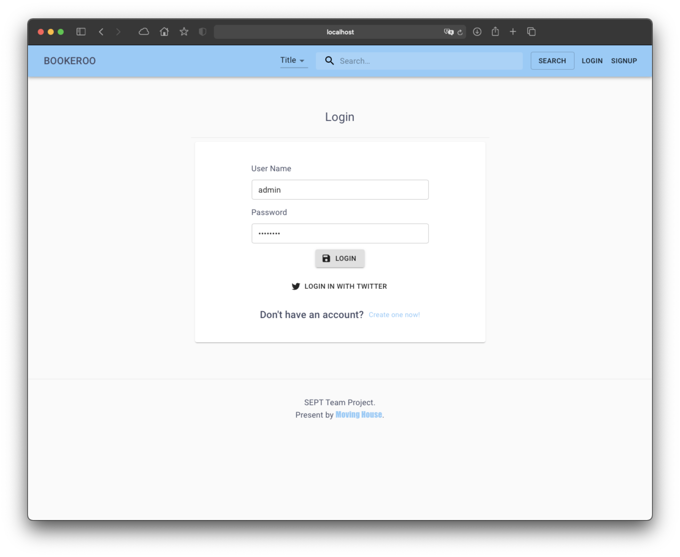

After successfully logged in, admin will be redirected to admin dashboard

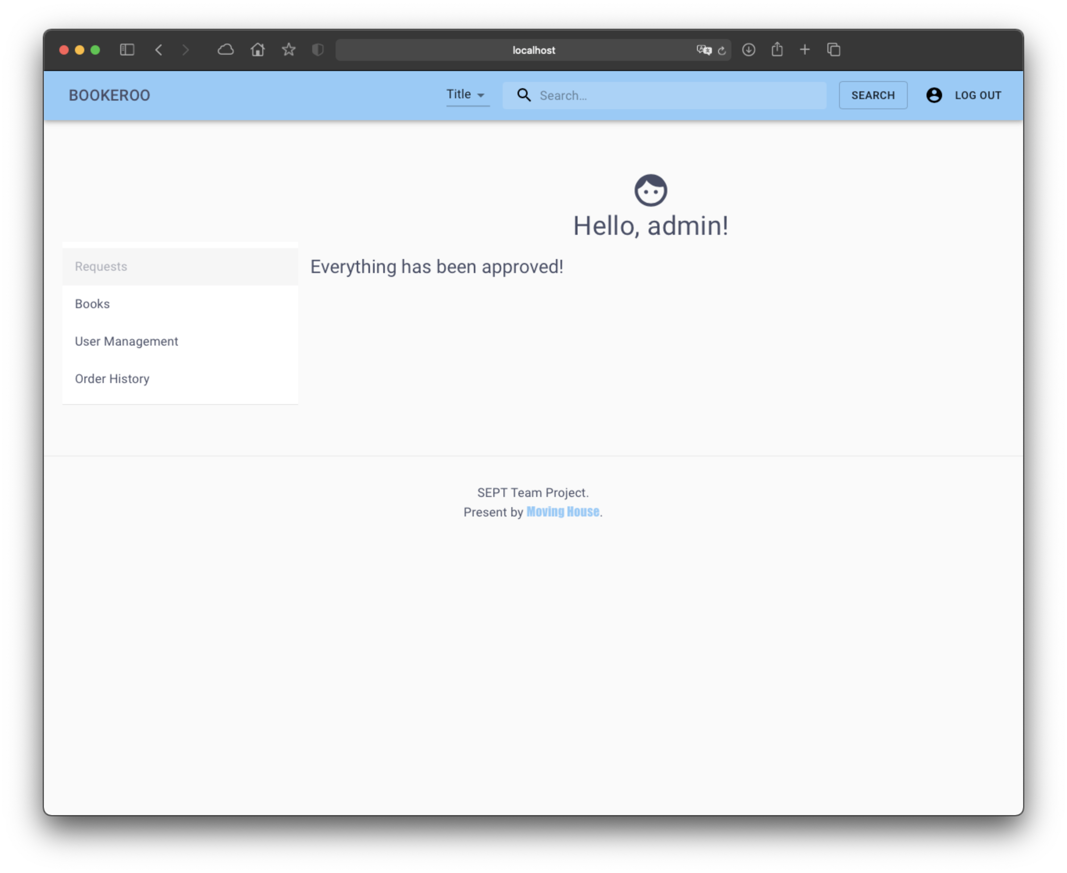

# As an Admin, I want to view all current users, so that I can see all user information.

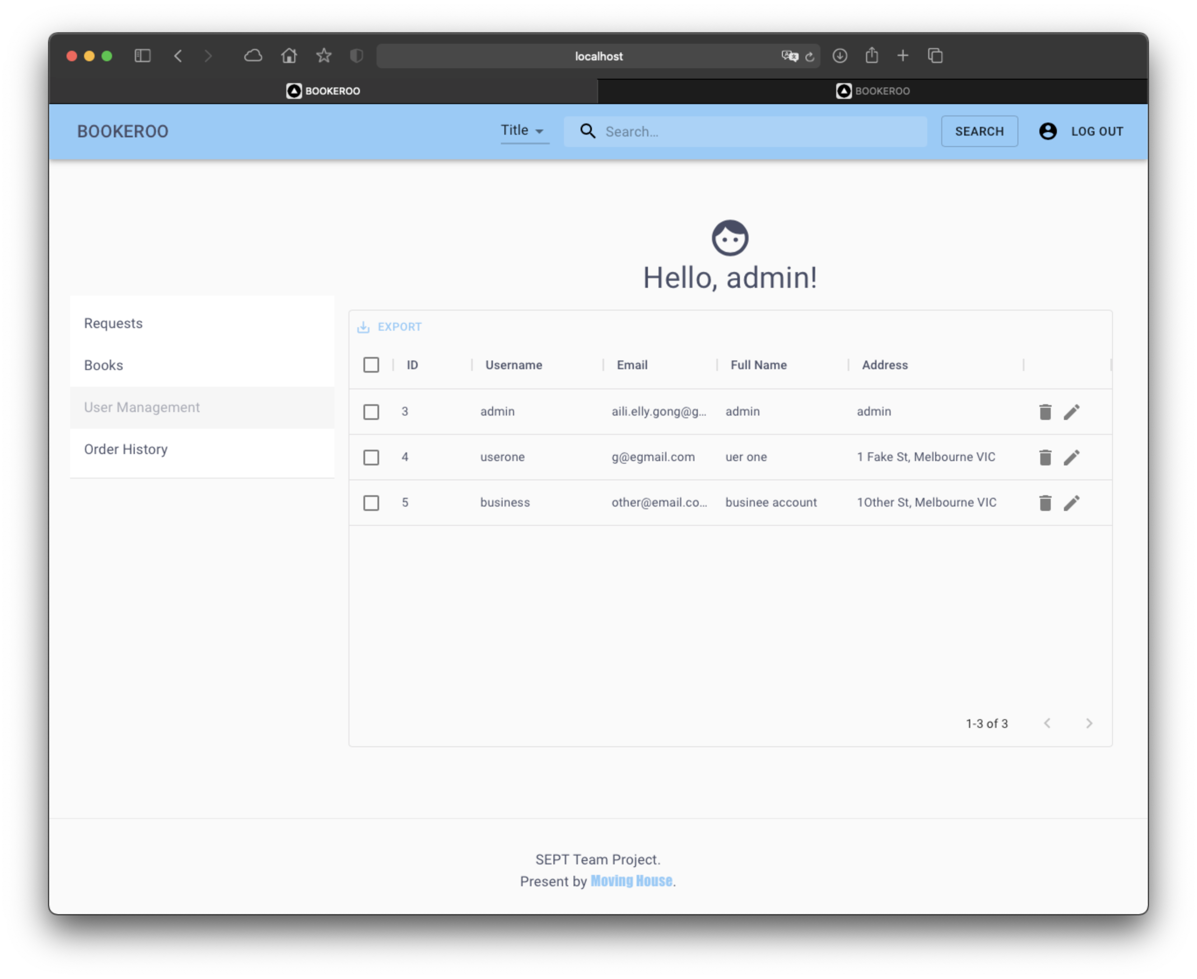

# As an Admin, I want to modify users, so that I can suspend/unsuspend users from their account.

Admin will be able to change the user status to suspend/unsuspend user account

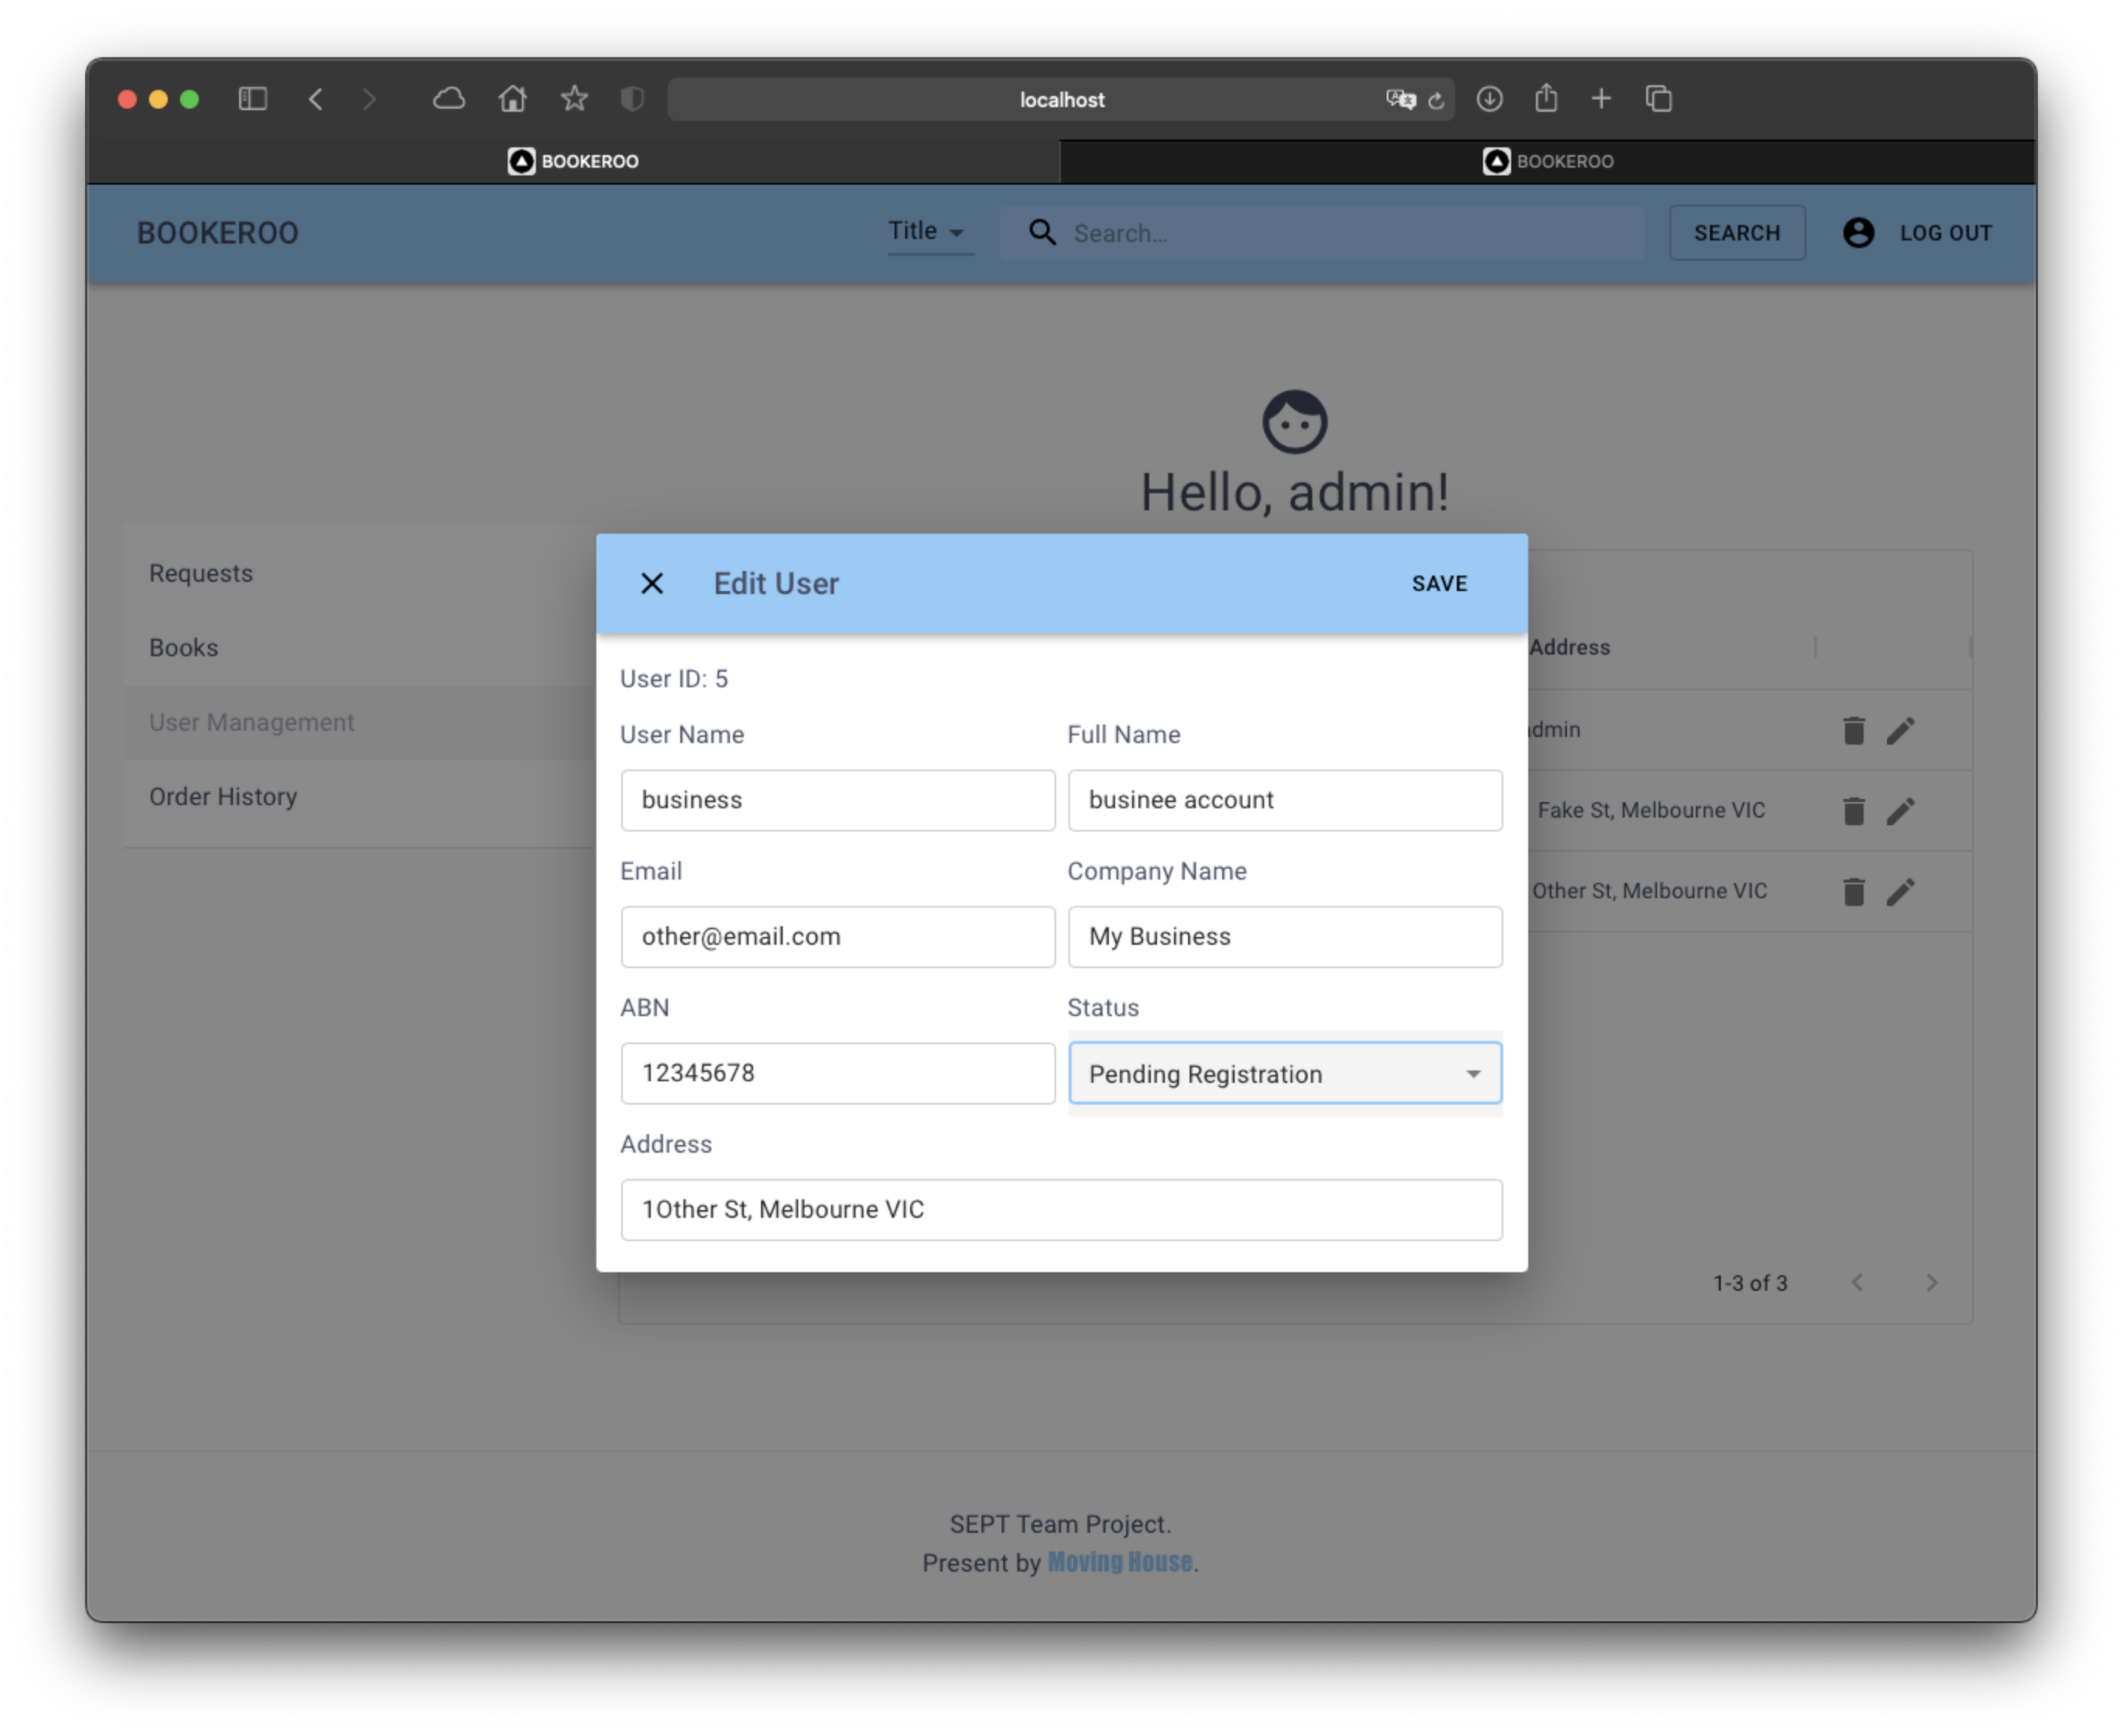

After click the save button, information will be updated in database.

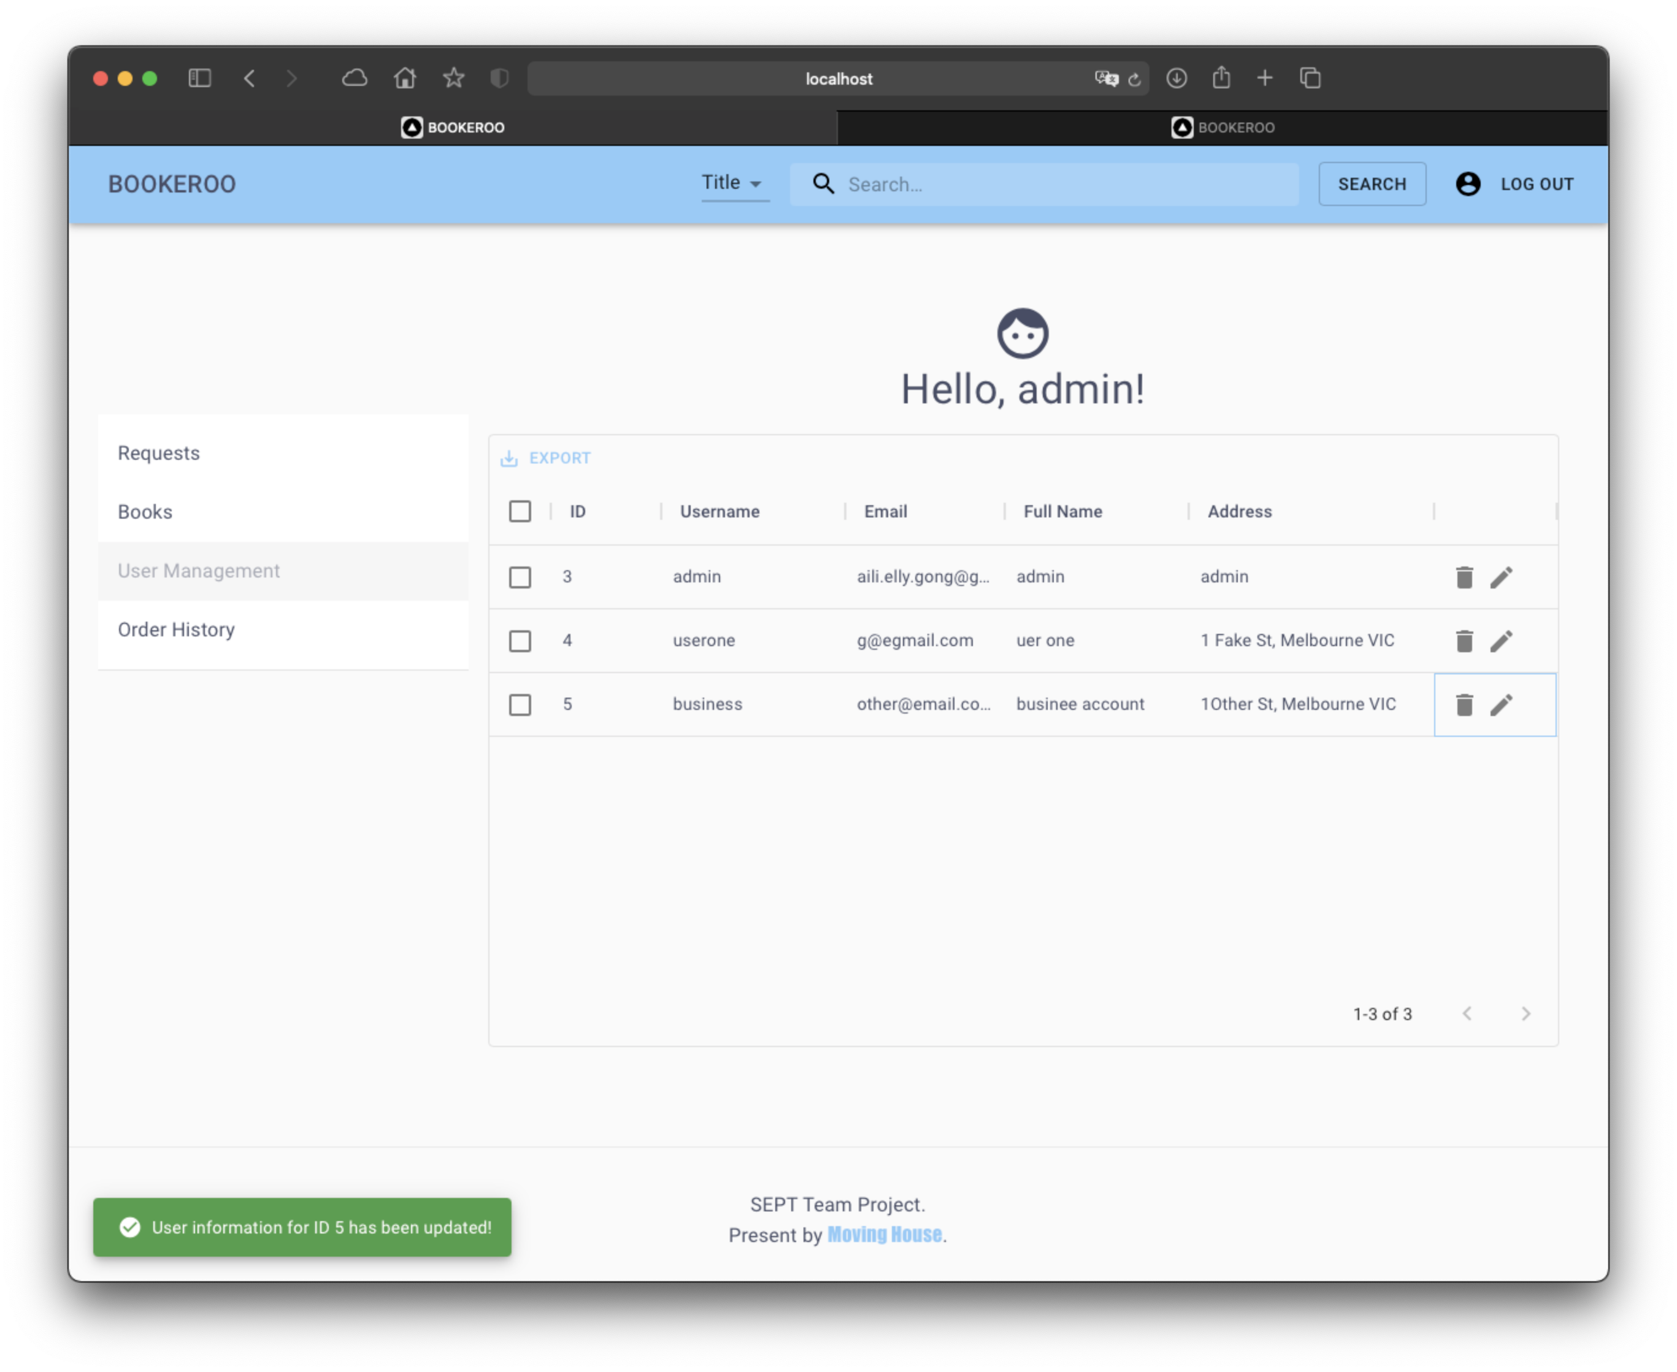

# As an Admin, I want to modify user accounts, so that I can edit user information.

Admin will be able to open the dialog to edit user information which will be save to database.

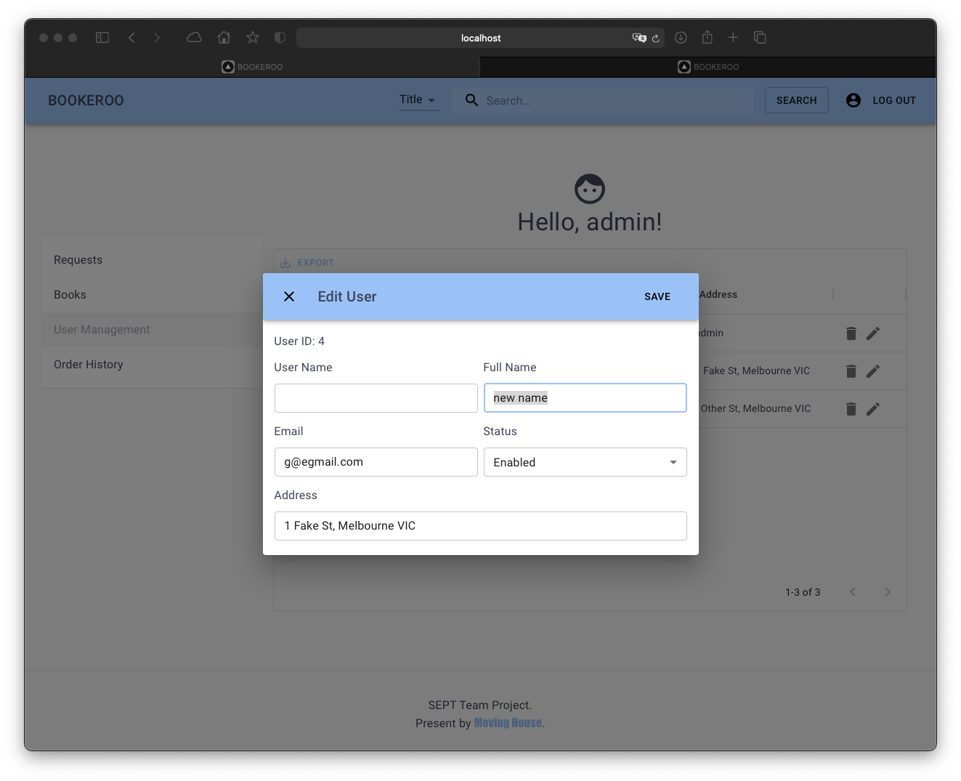

# As an Admin, I want to add new books, so that new items can be sold.

In the book tab, there is a add button for admin to add a new book.

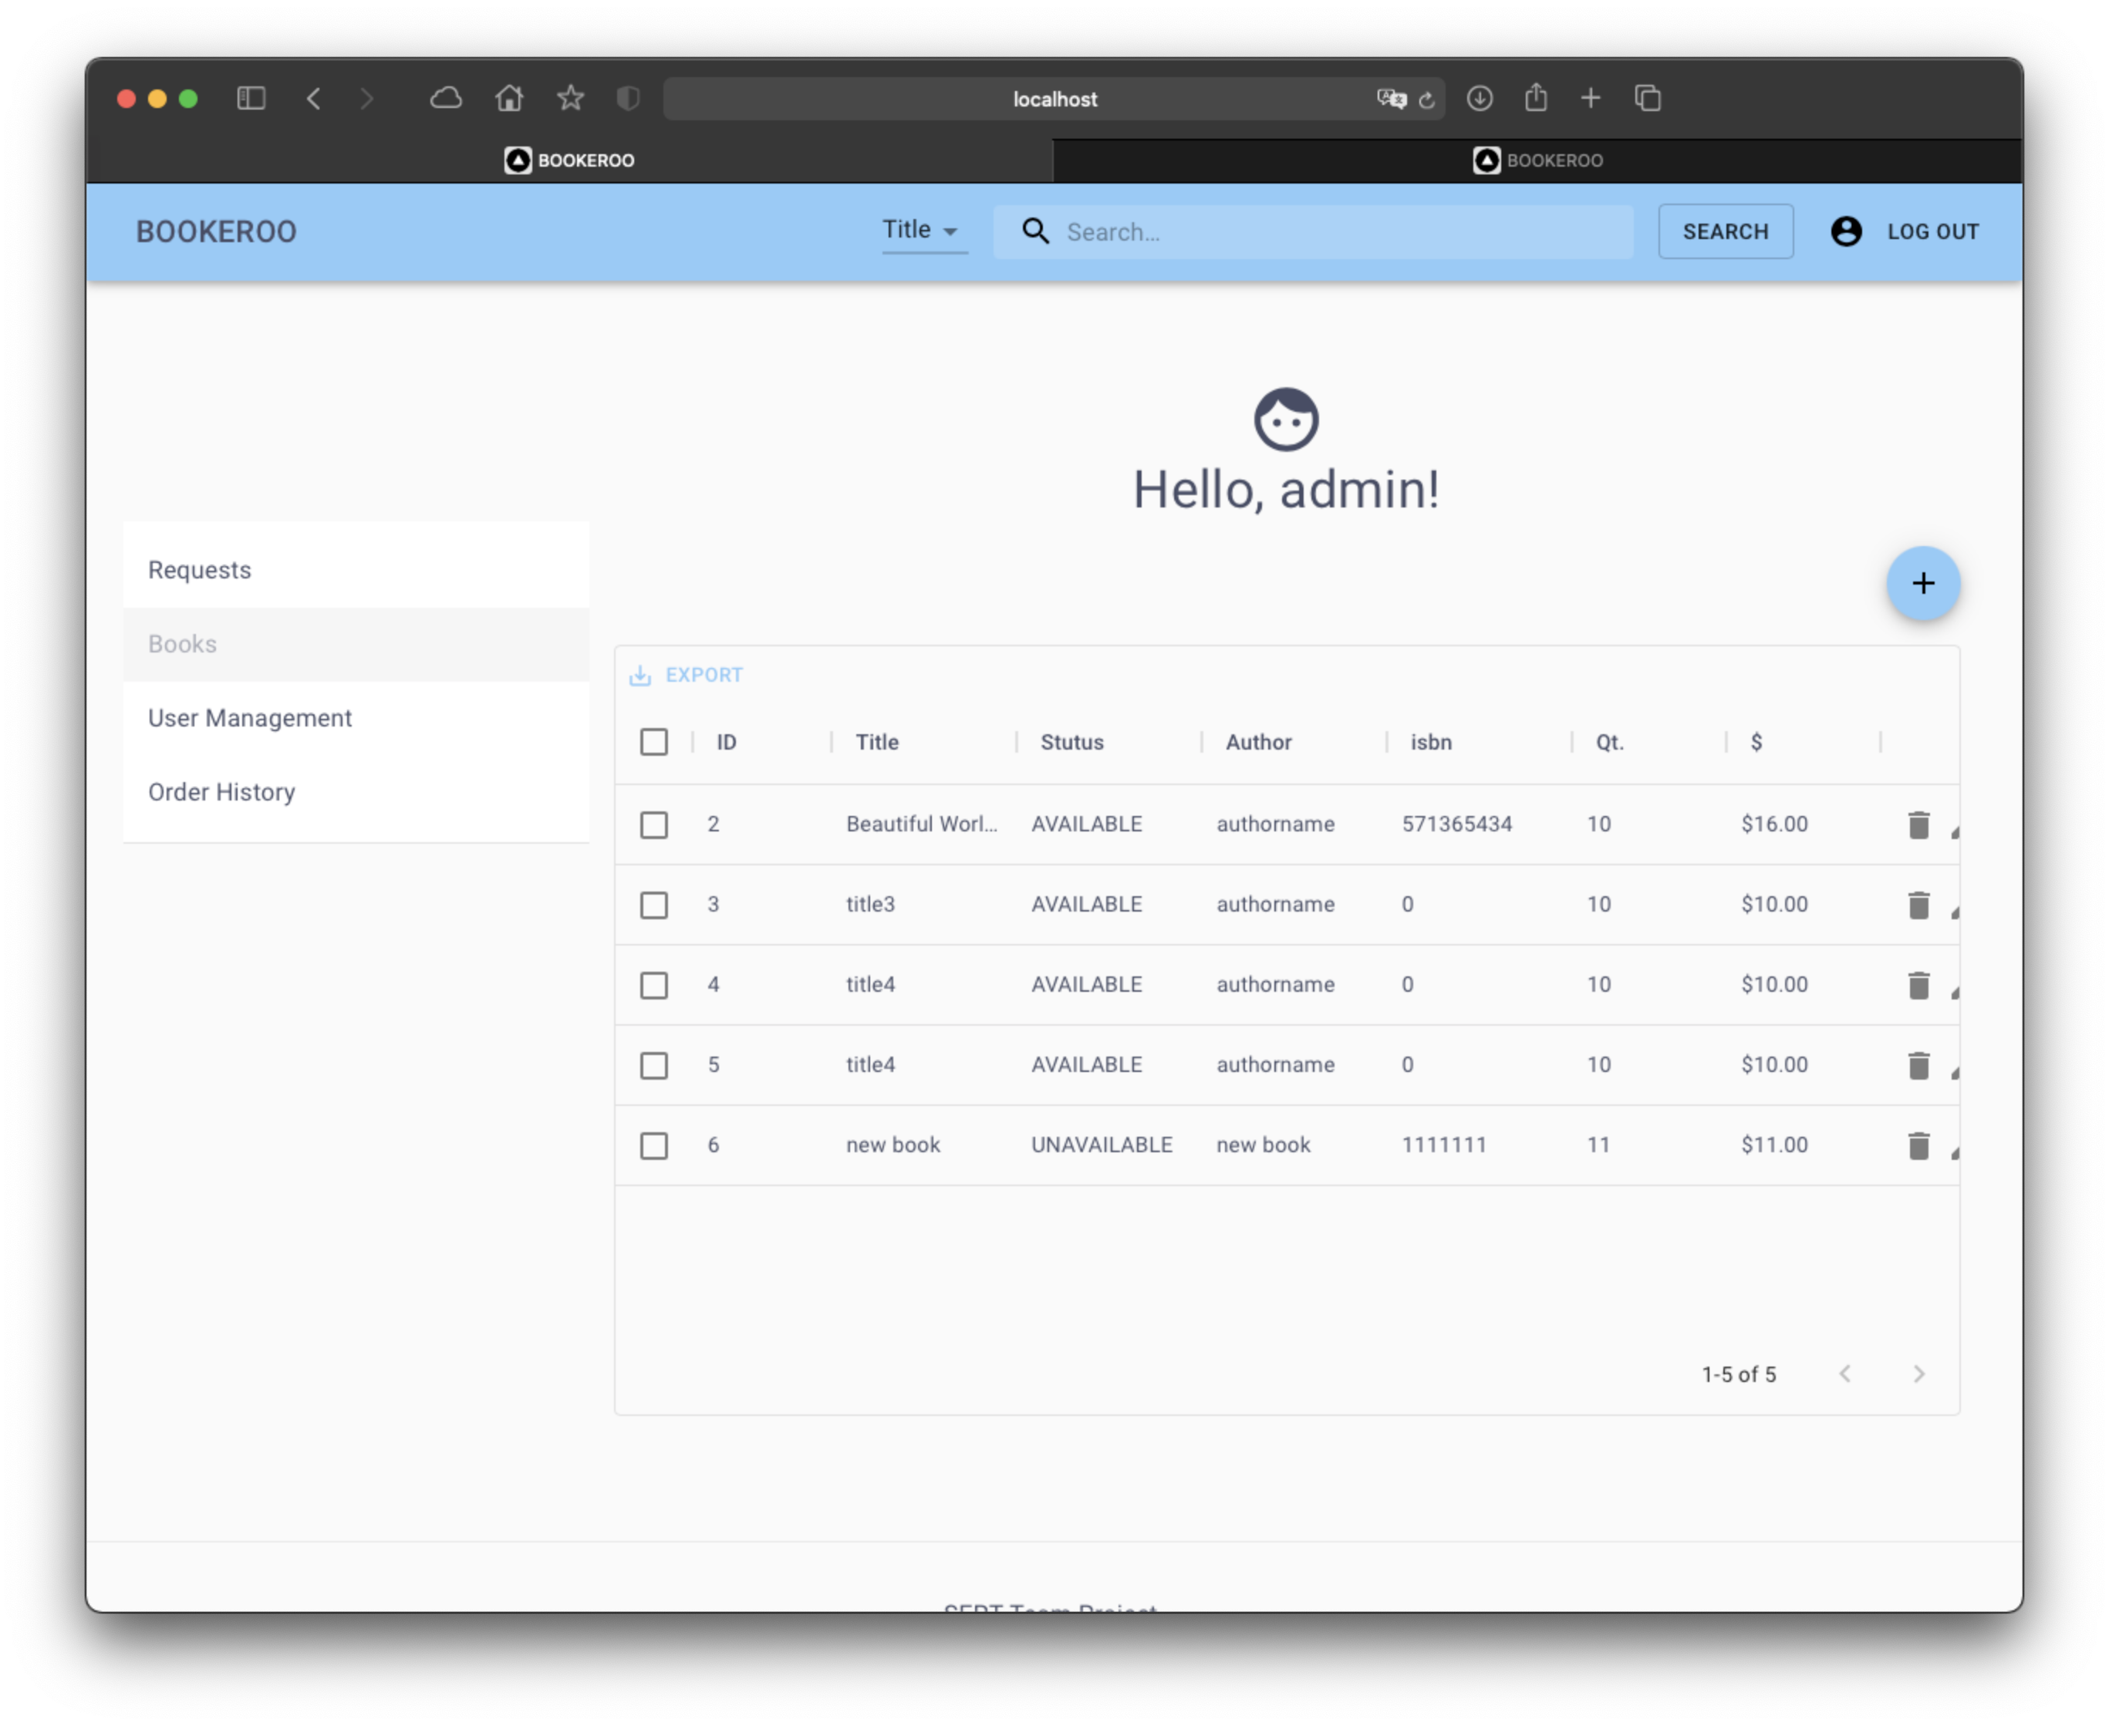

Admin will be able to fill all book info and save to database

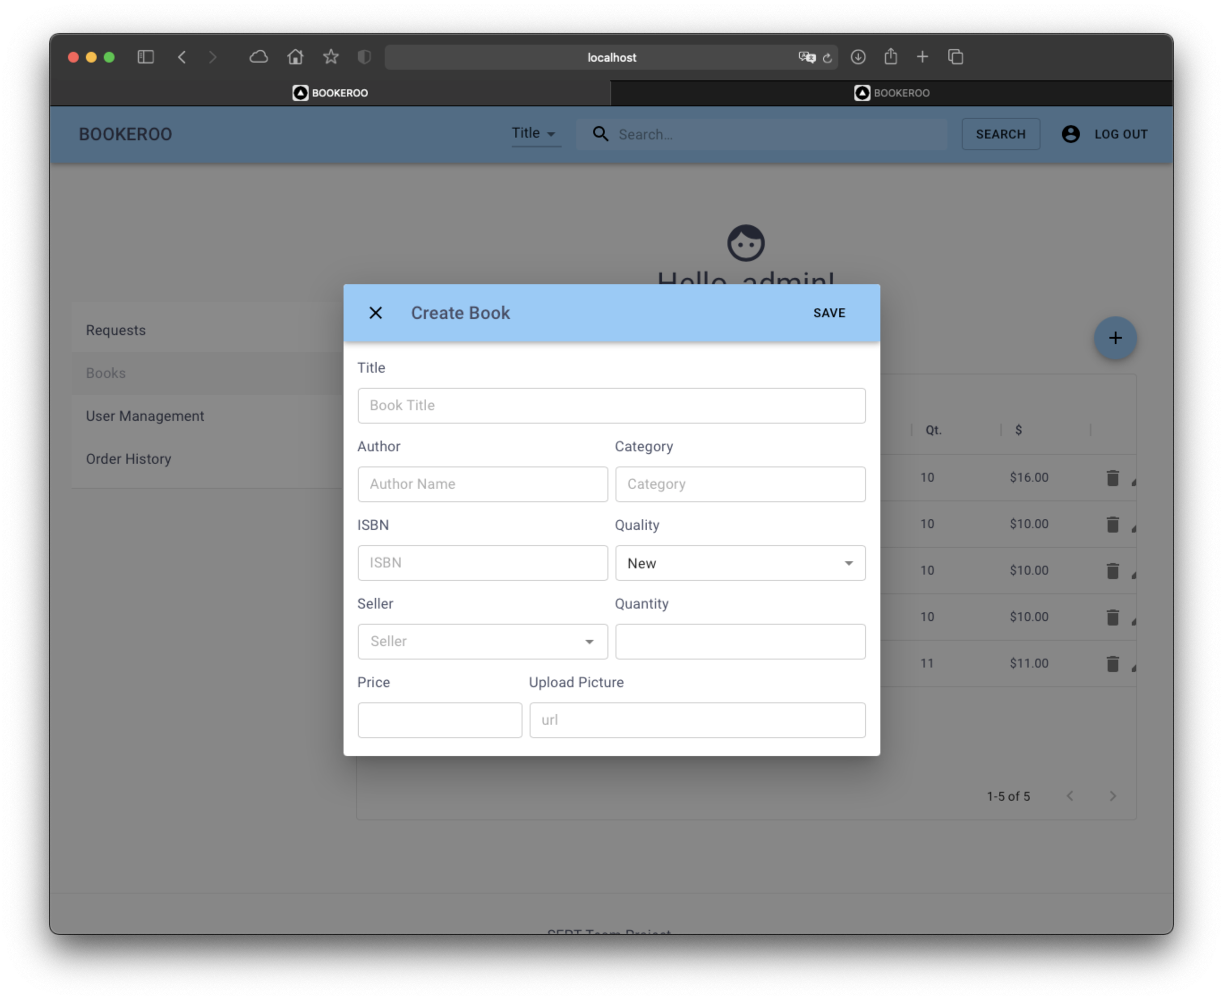

# As an Admin, I want to edit books, so that I can update the correct data.

in the book tab, admin will be able to click the edit button to edit book info.

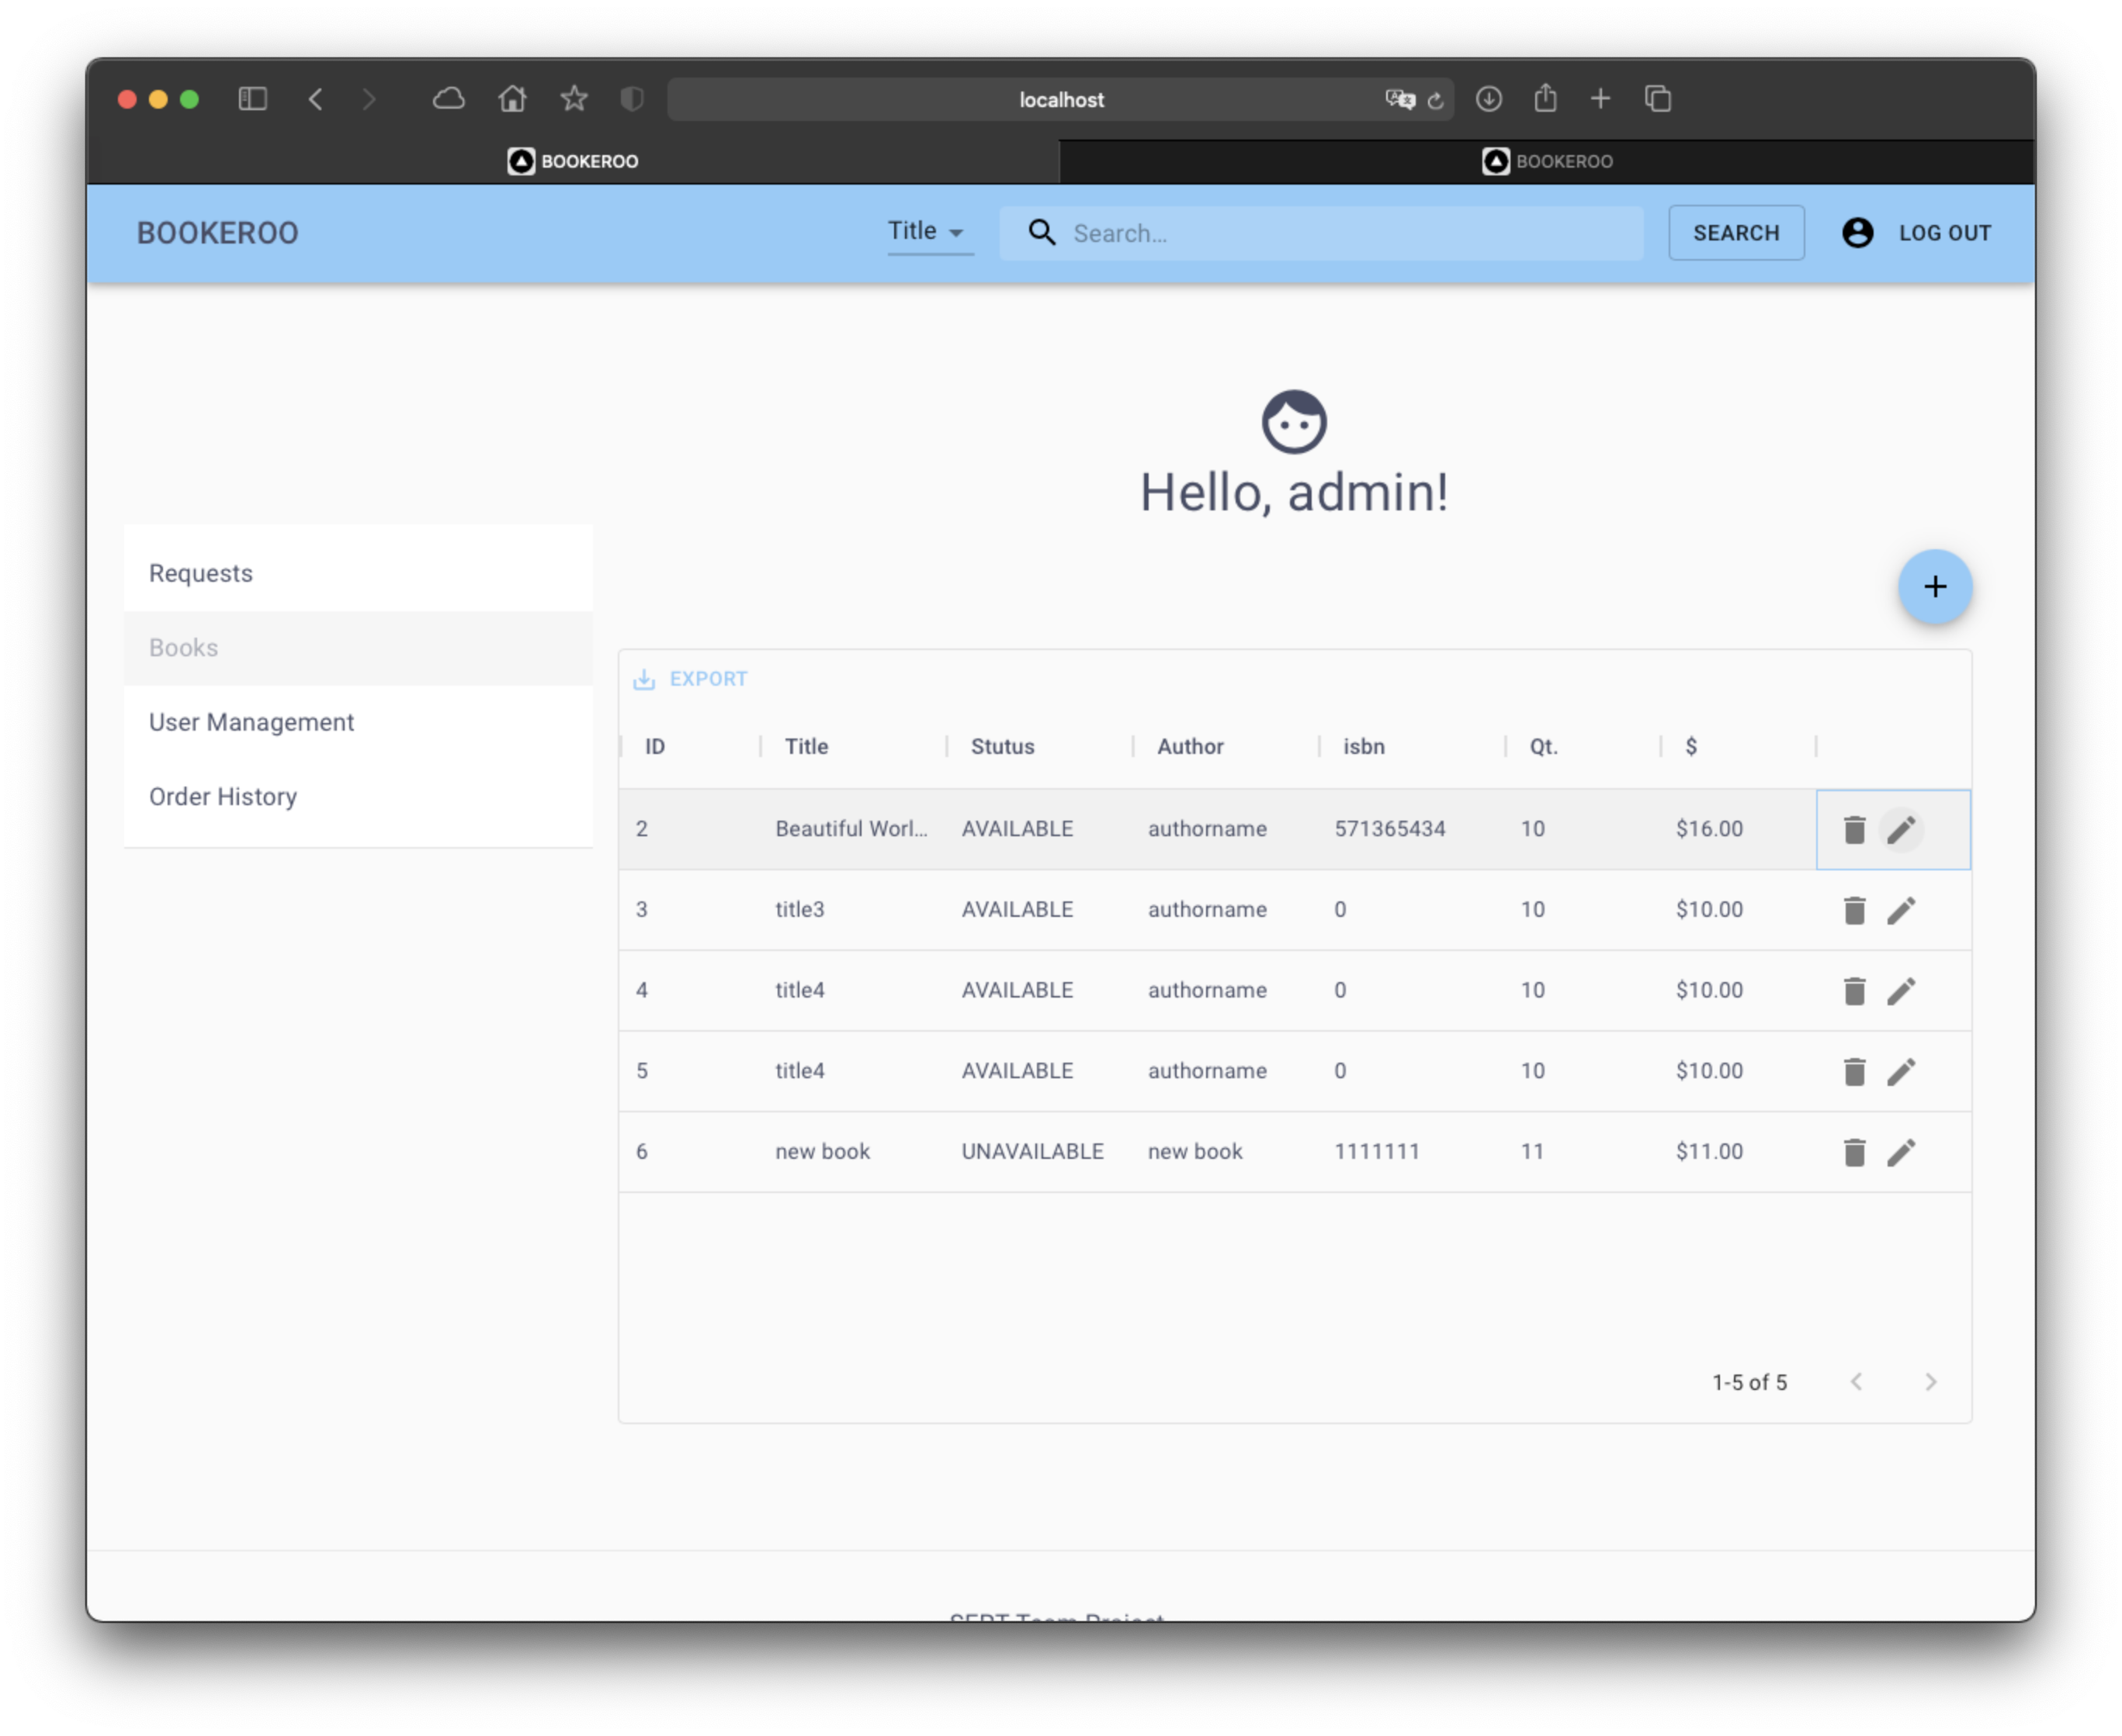

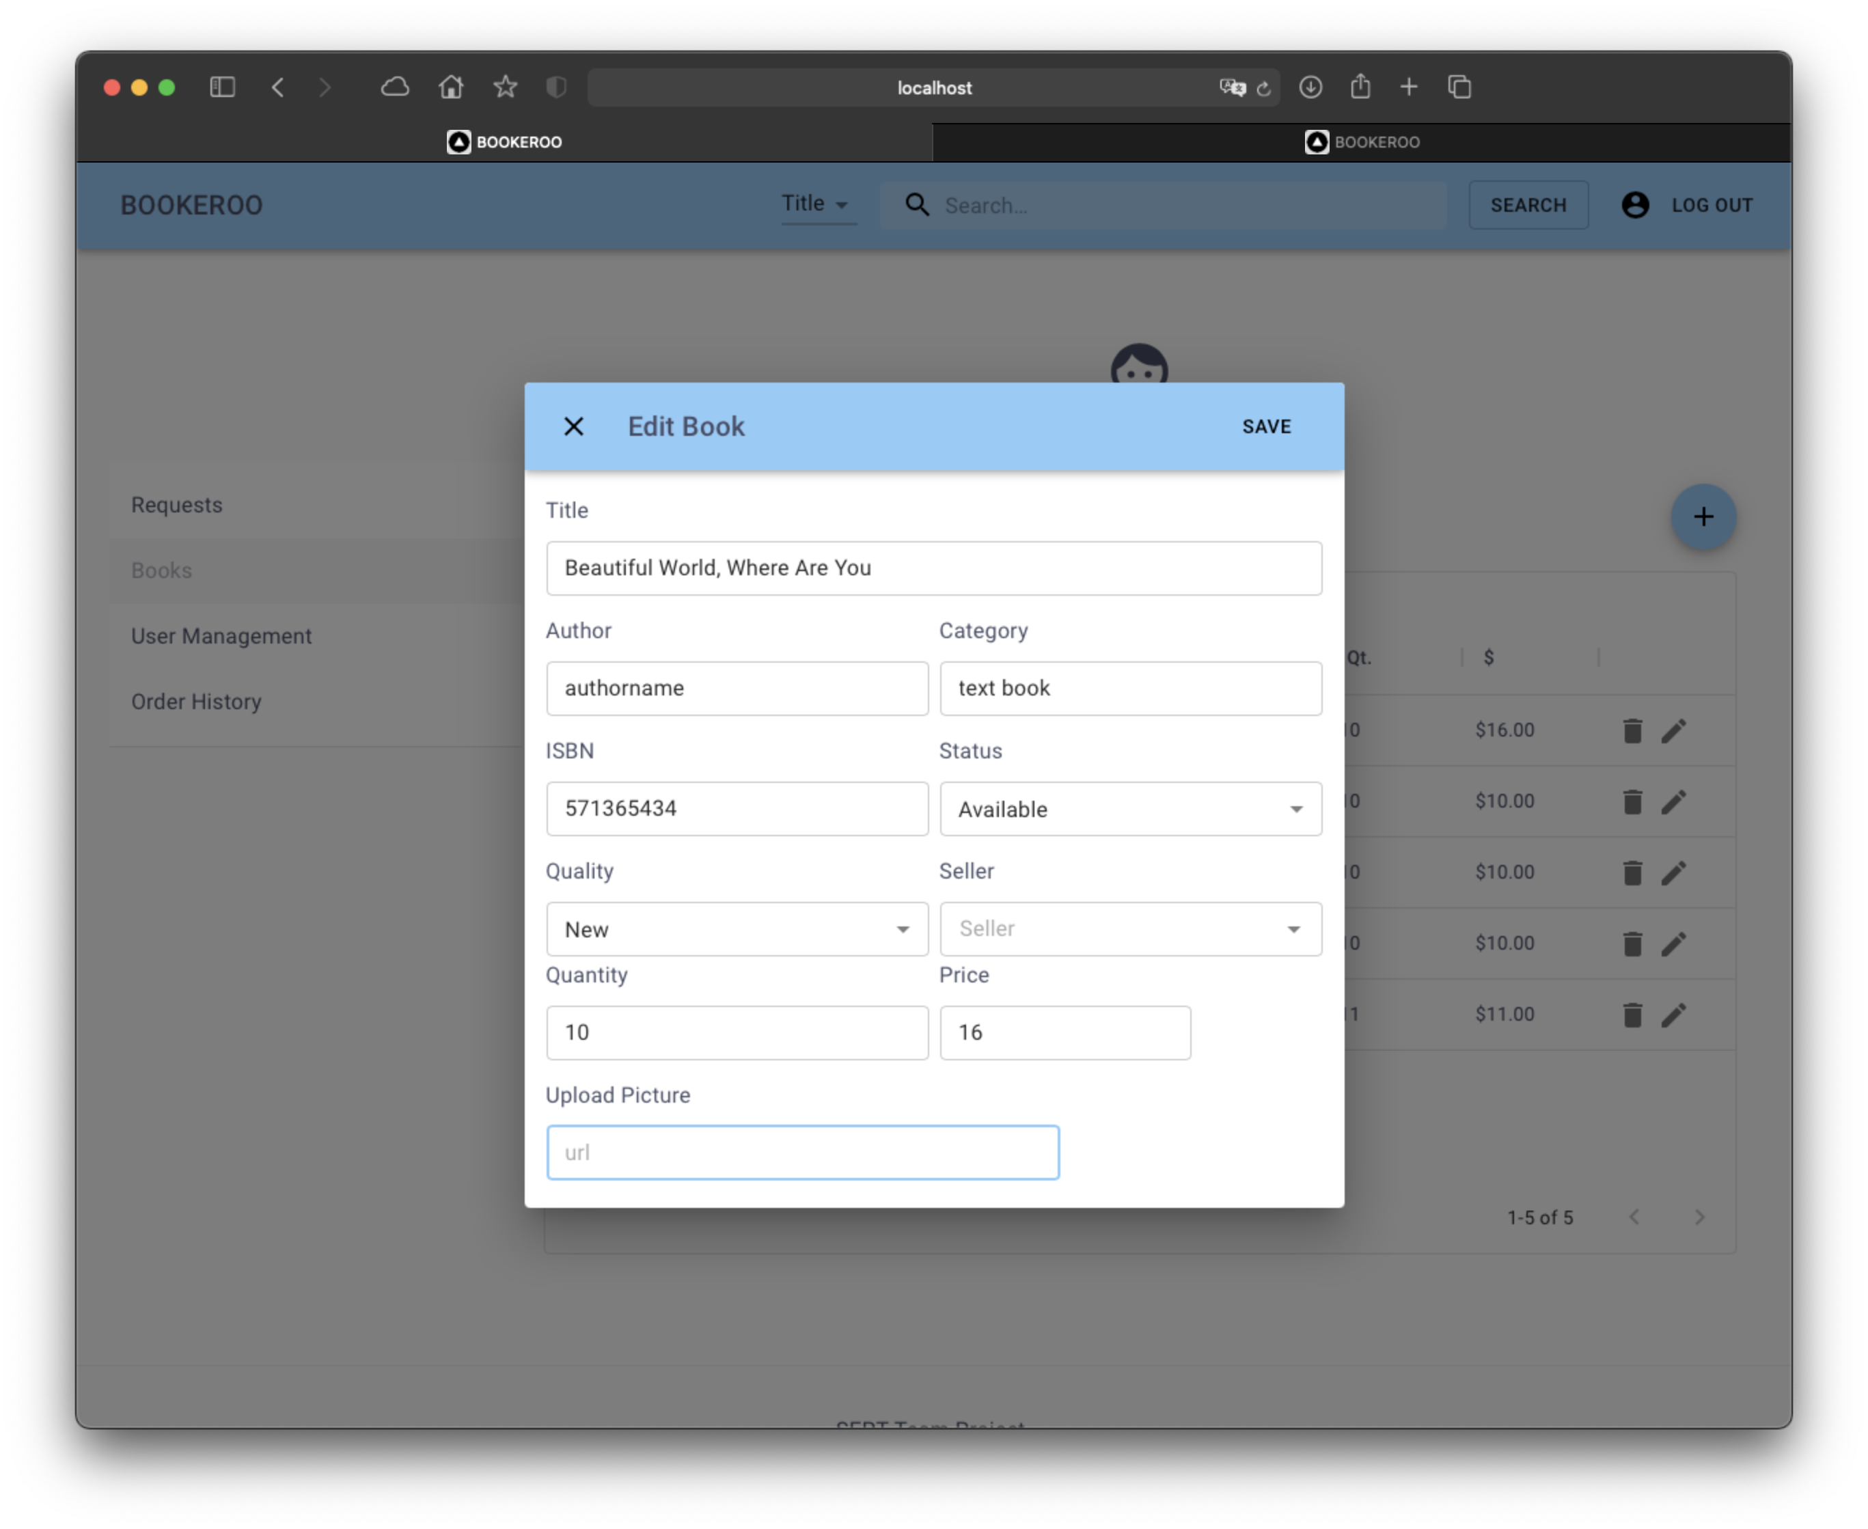

# As a business user, I want to be able to login to my business account so that I can access my business profile

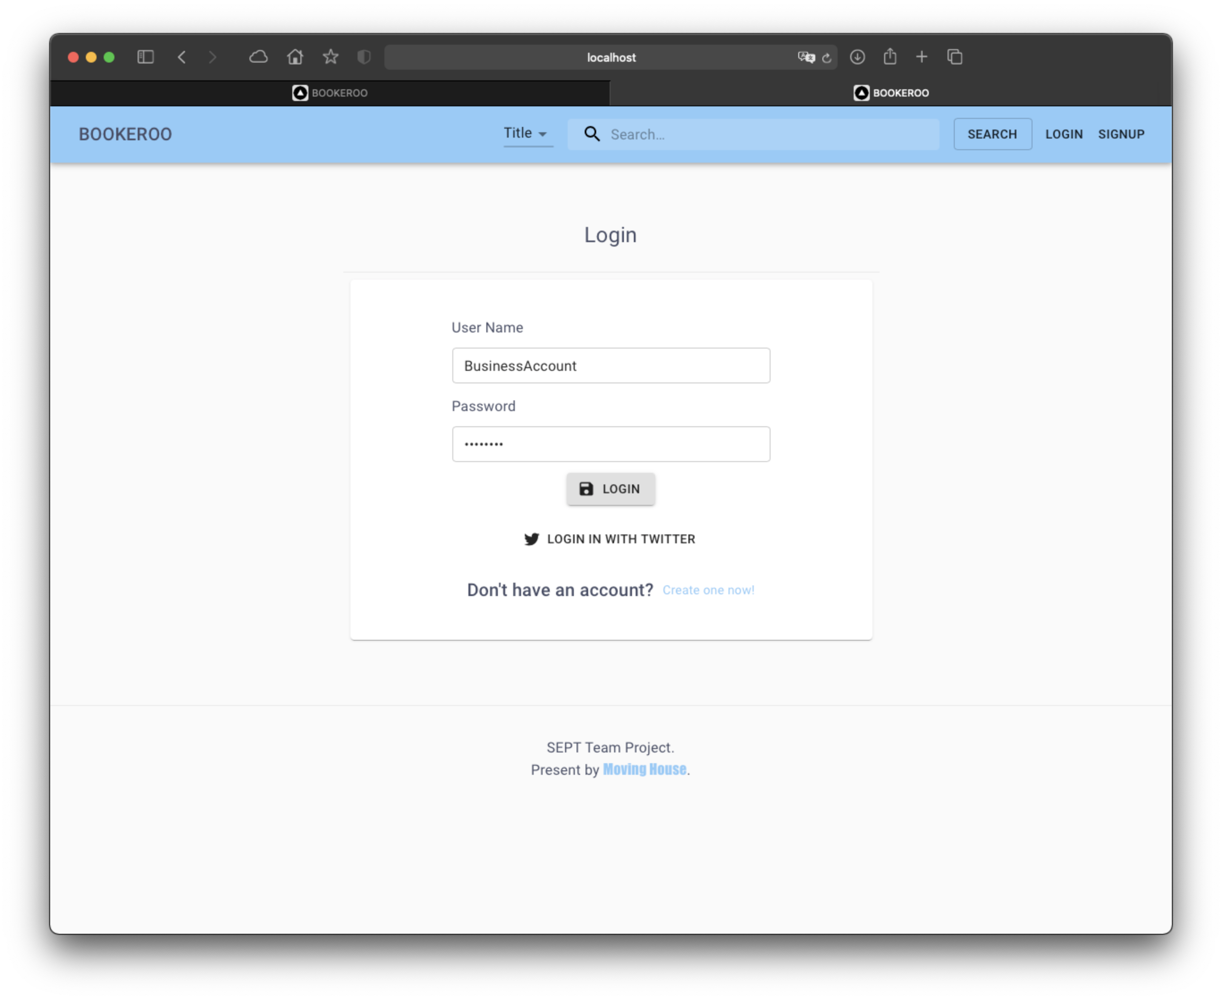

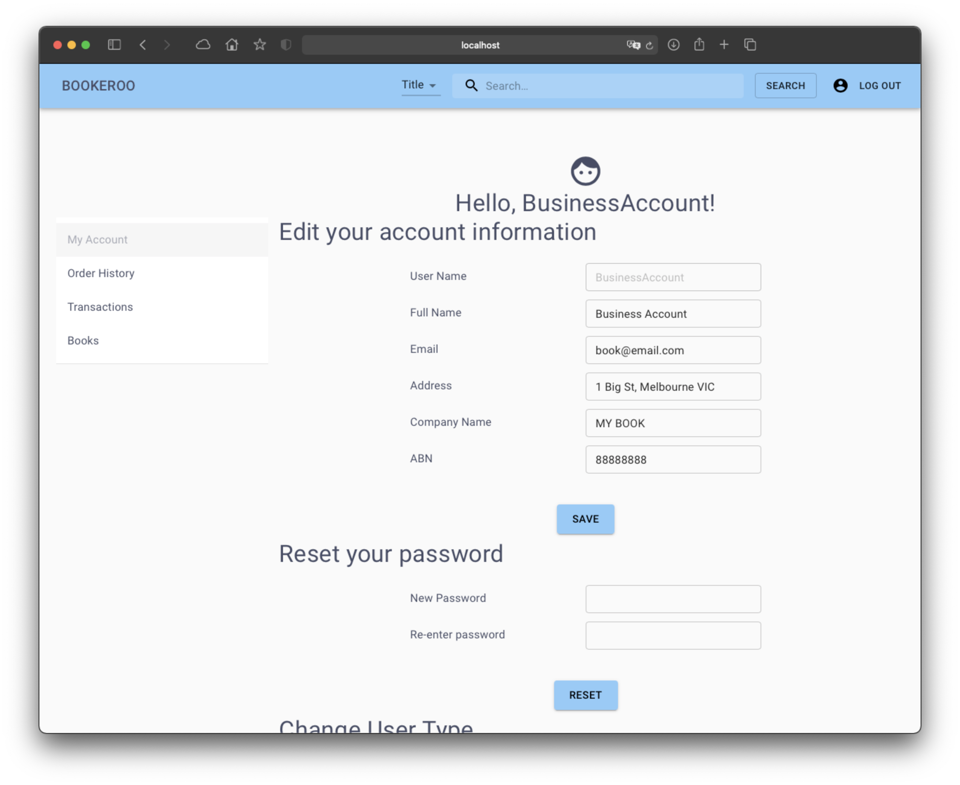

# As a business user, I want to be able to see all previous transactions, so I know how often transactions are happening.

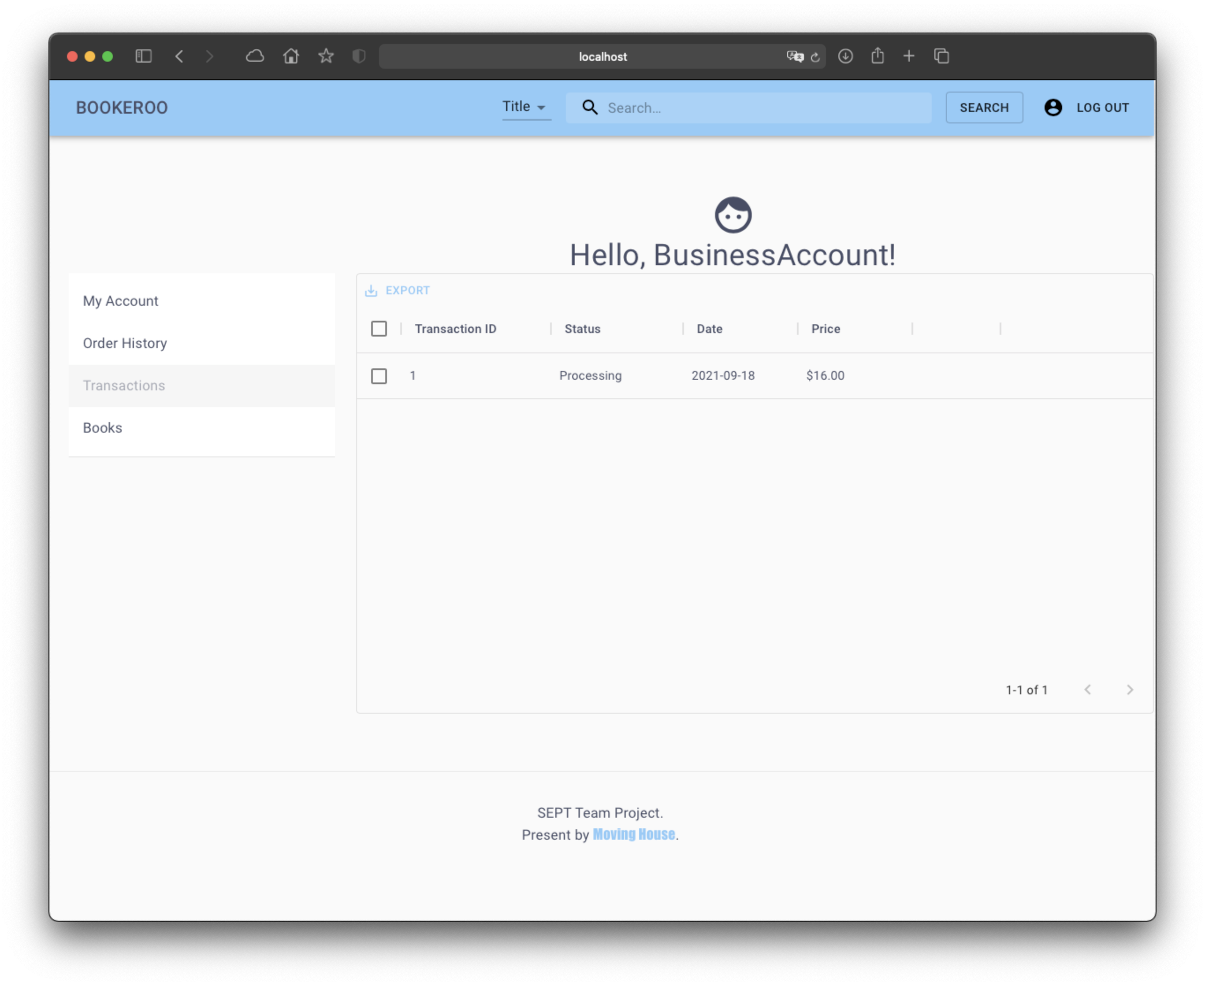

# As a business user, I want to be able to edit the books I am managing, so I can fix mistakes when originally created the book page.

User will be able to see all books under this account

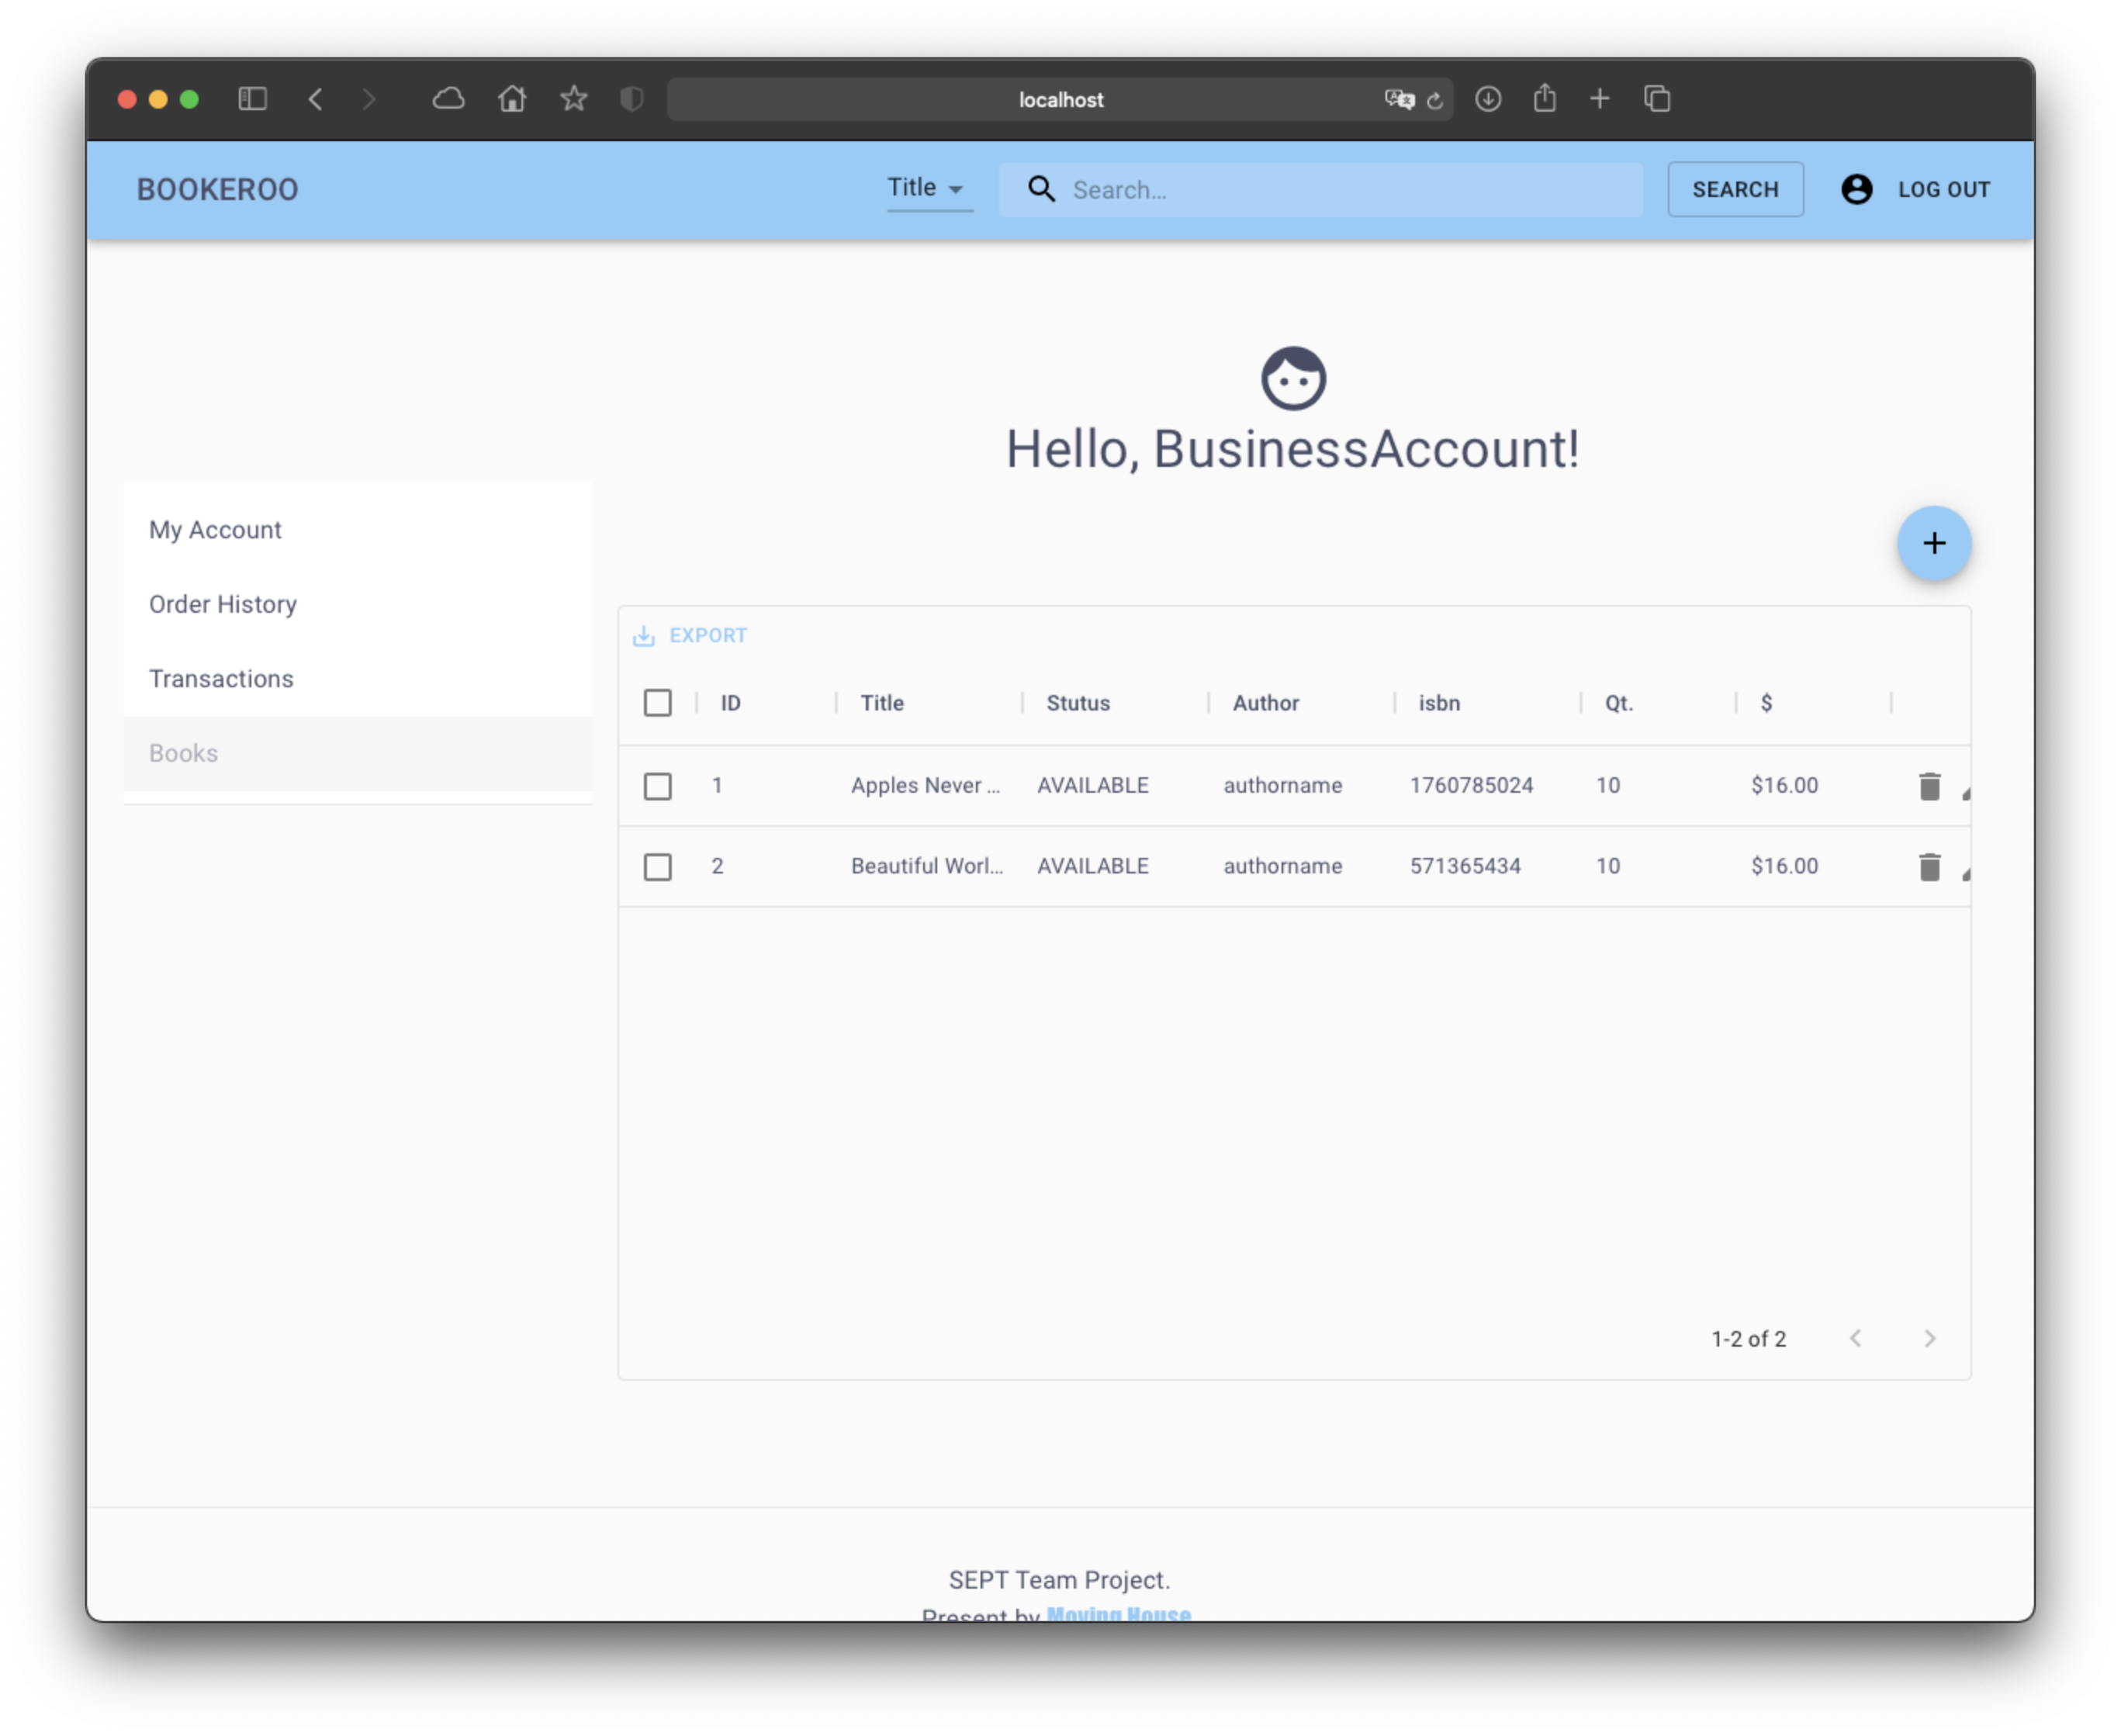by clicking the edit button, user will be able to edit the book info

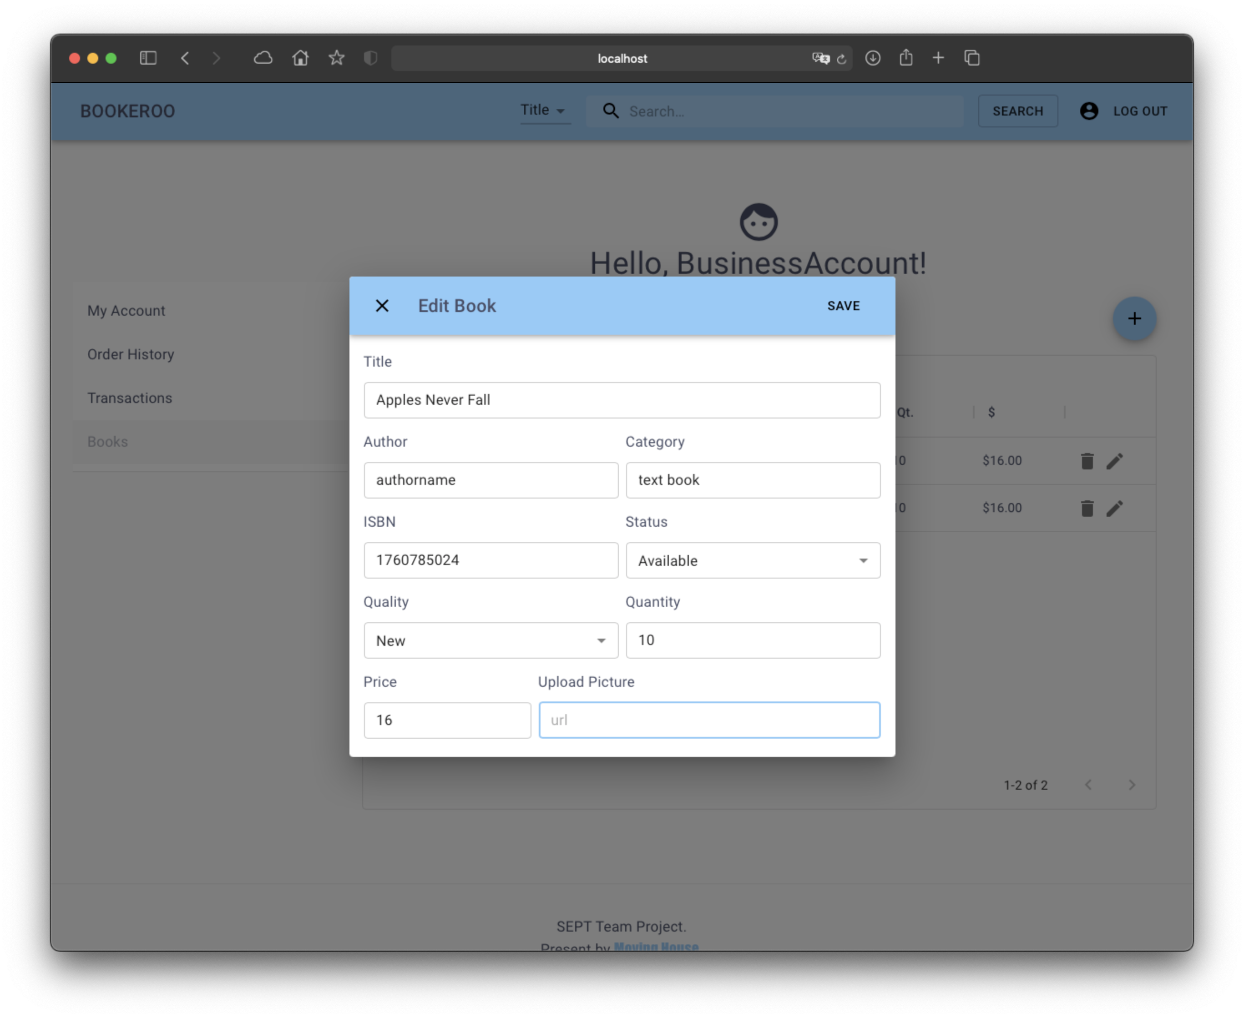

# As a customer, I want to view the details of the book I am thinking of buying, so I can be more informed on my decision.

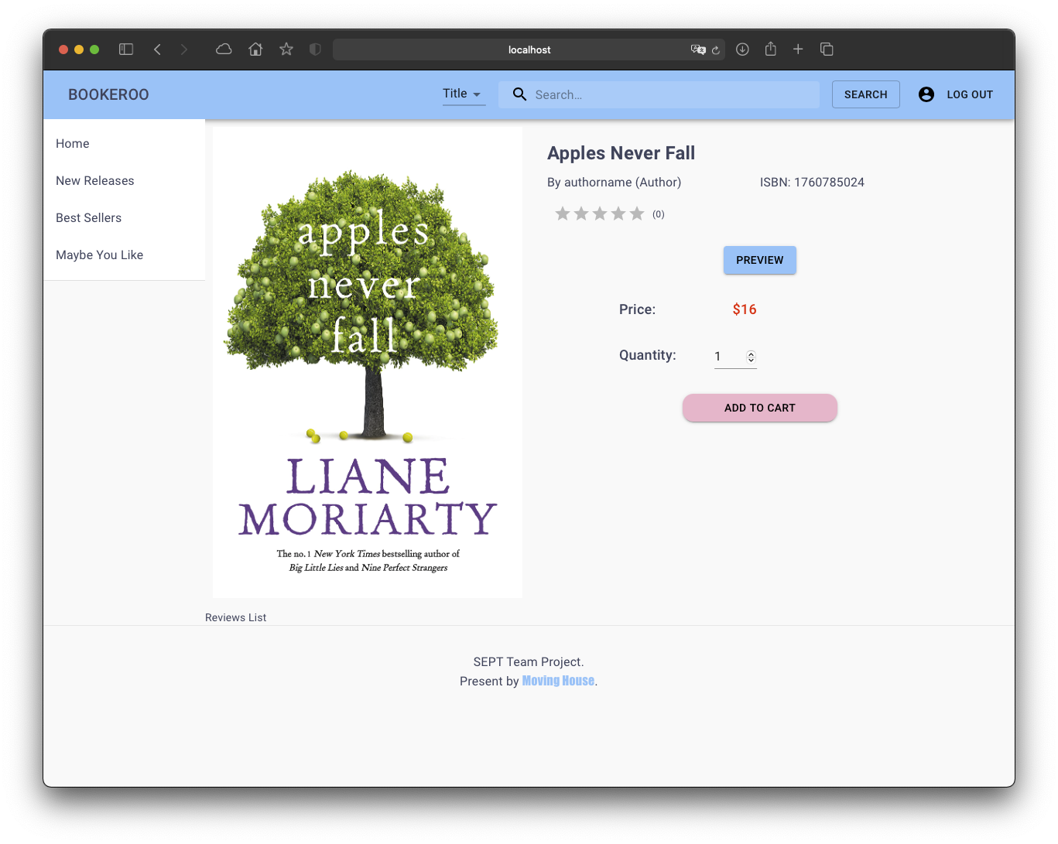

# As an admin, I want to approve a pending registration from a business user so that they can open a new business account.

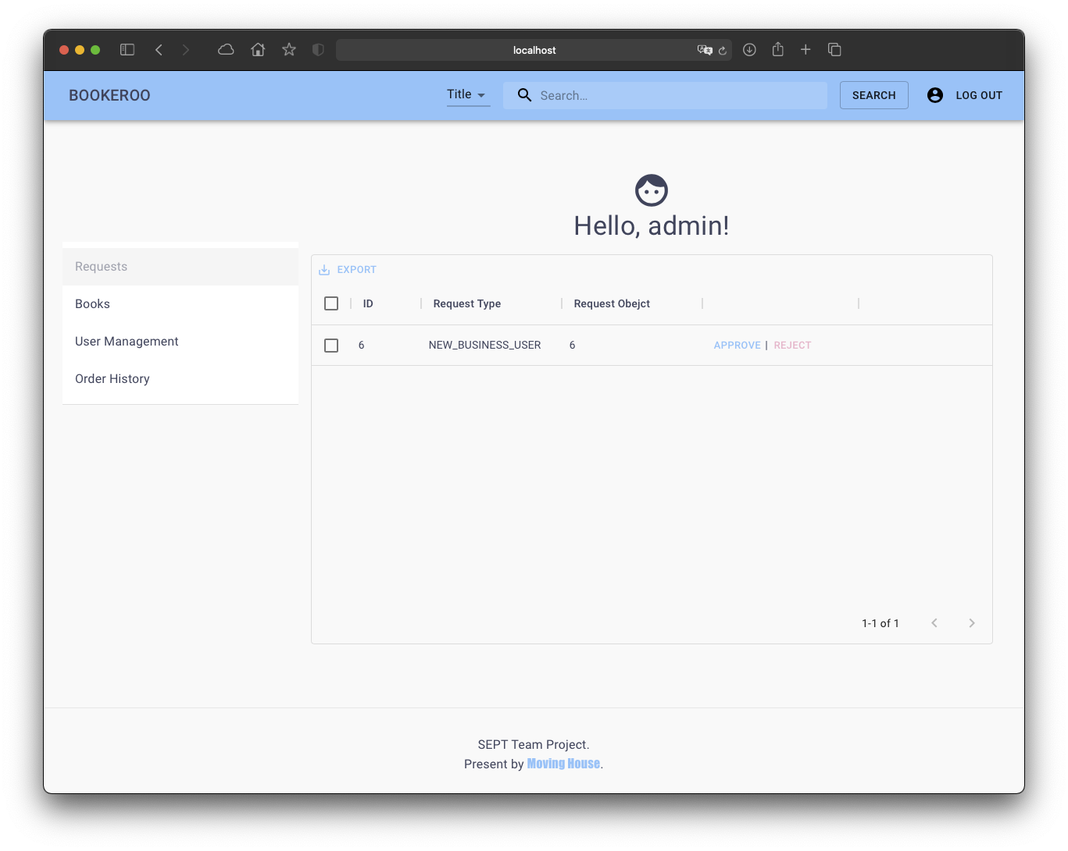

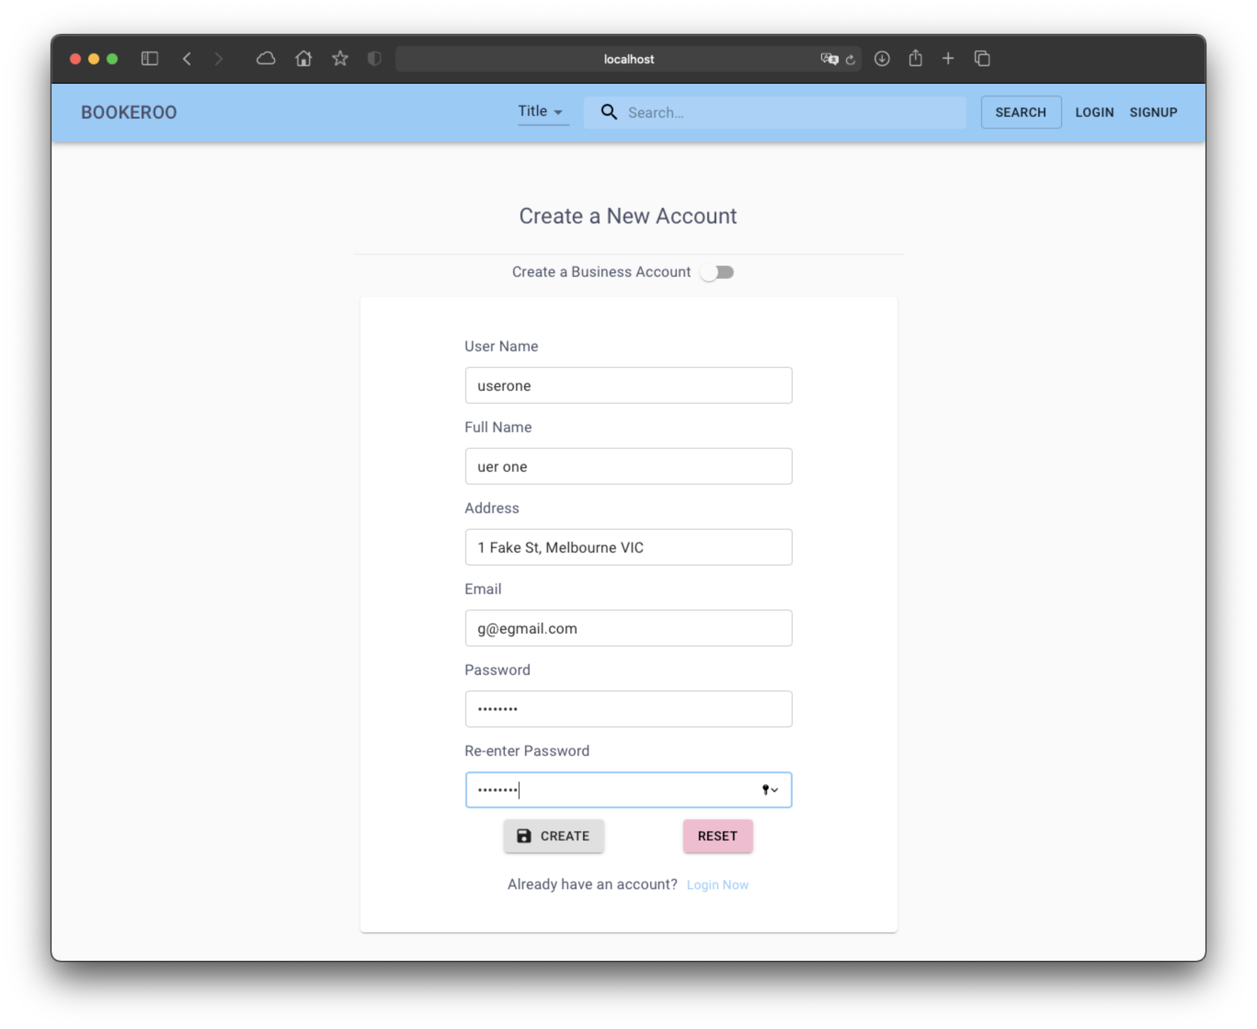

# As a customer, I want to be able to search for books so that I can view information about the book.

There is a search bar on the top which allows user search for a book.

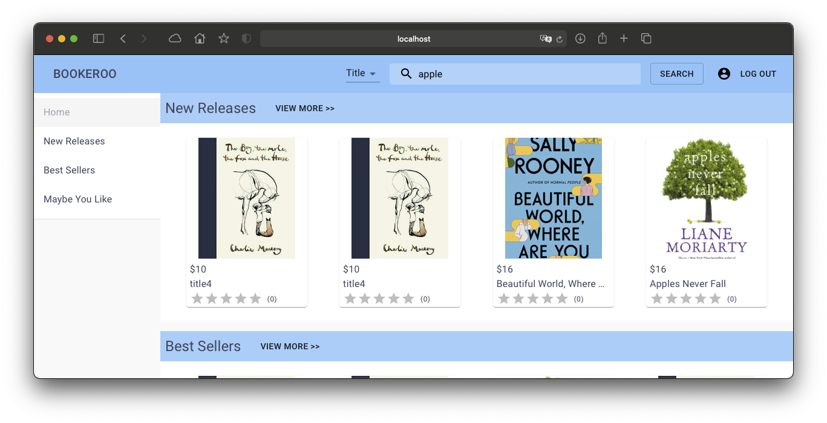

# As a Customer, I want to be able to view my transaction history, so that I can see all my recently bought books

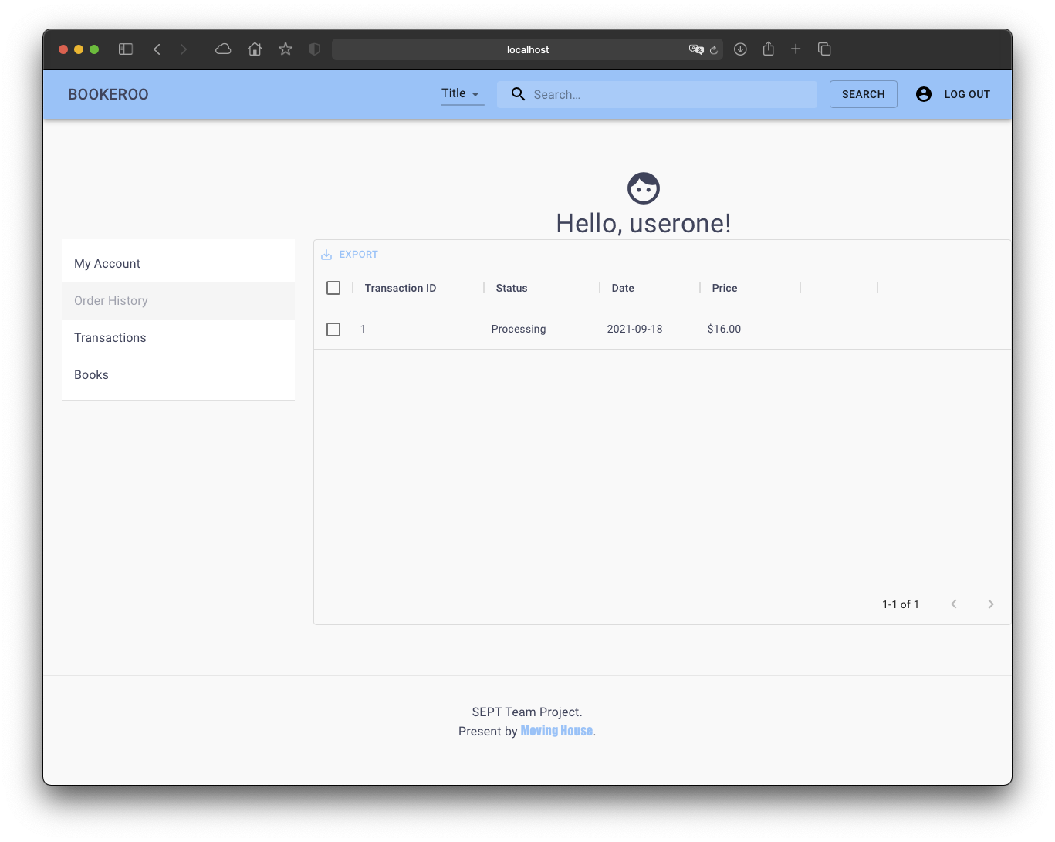

# As an admin, I want to approve a pending registration from a business user so that they can open a new business account.

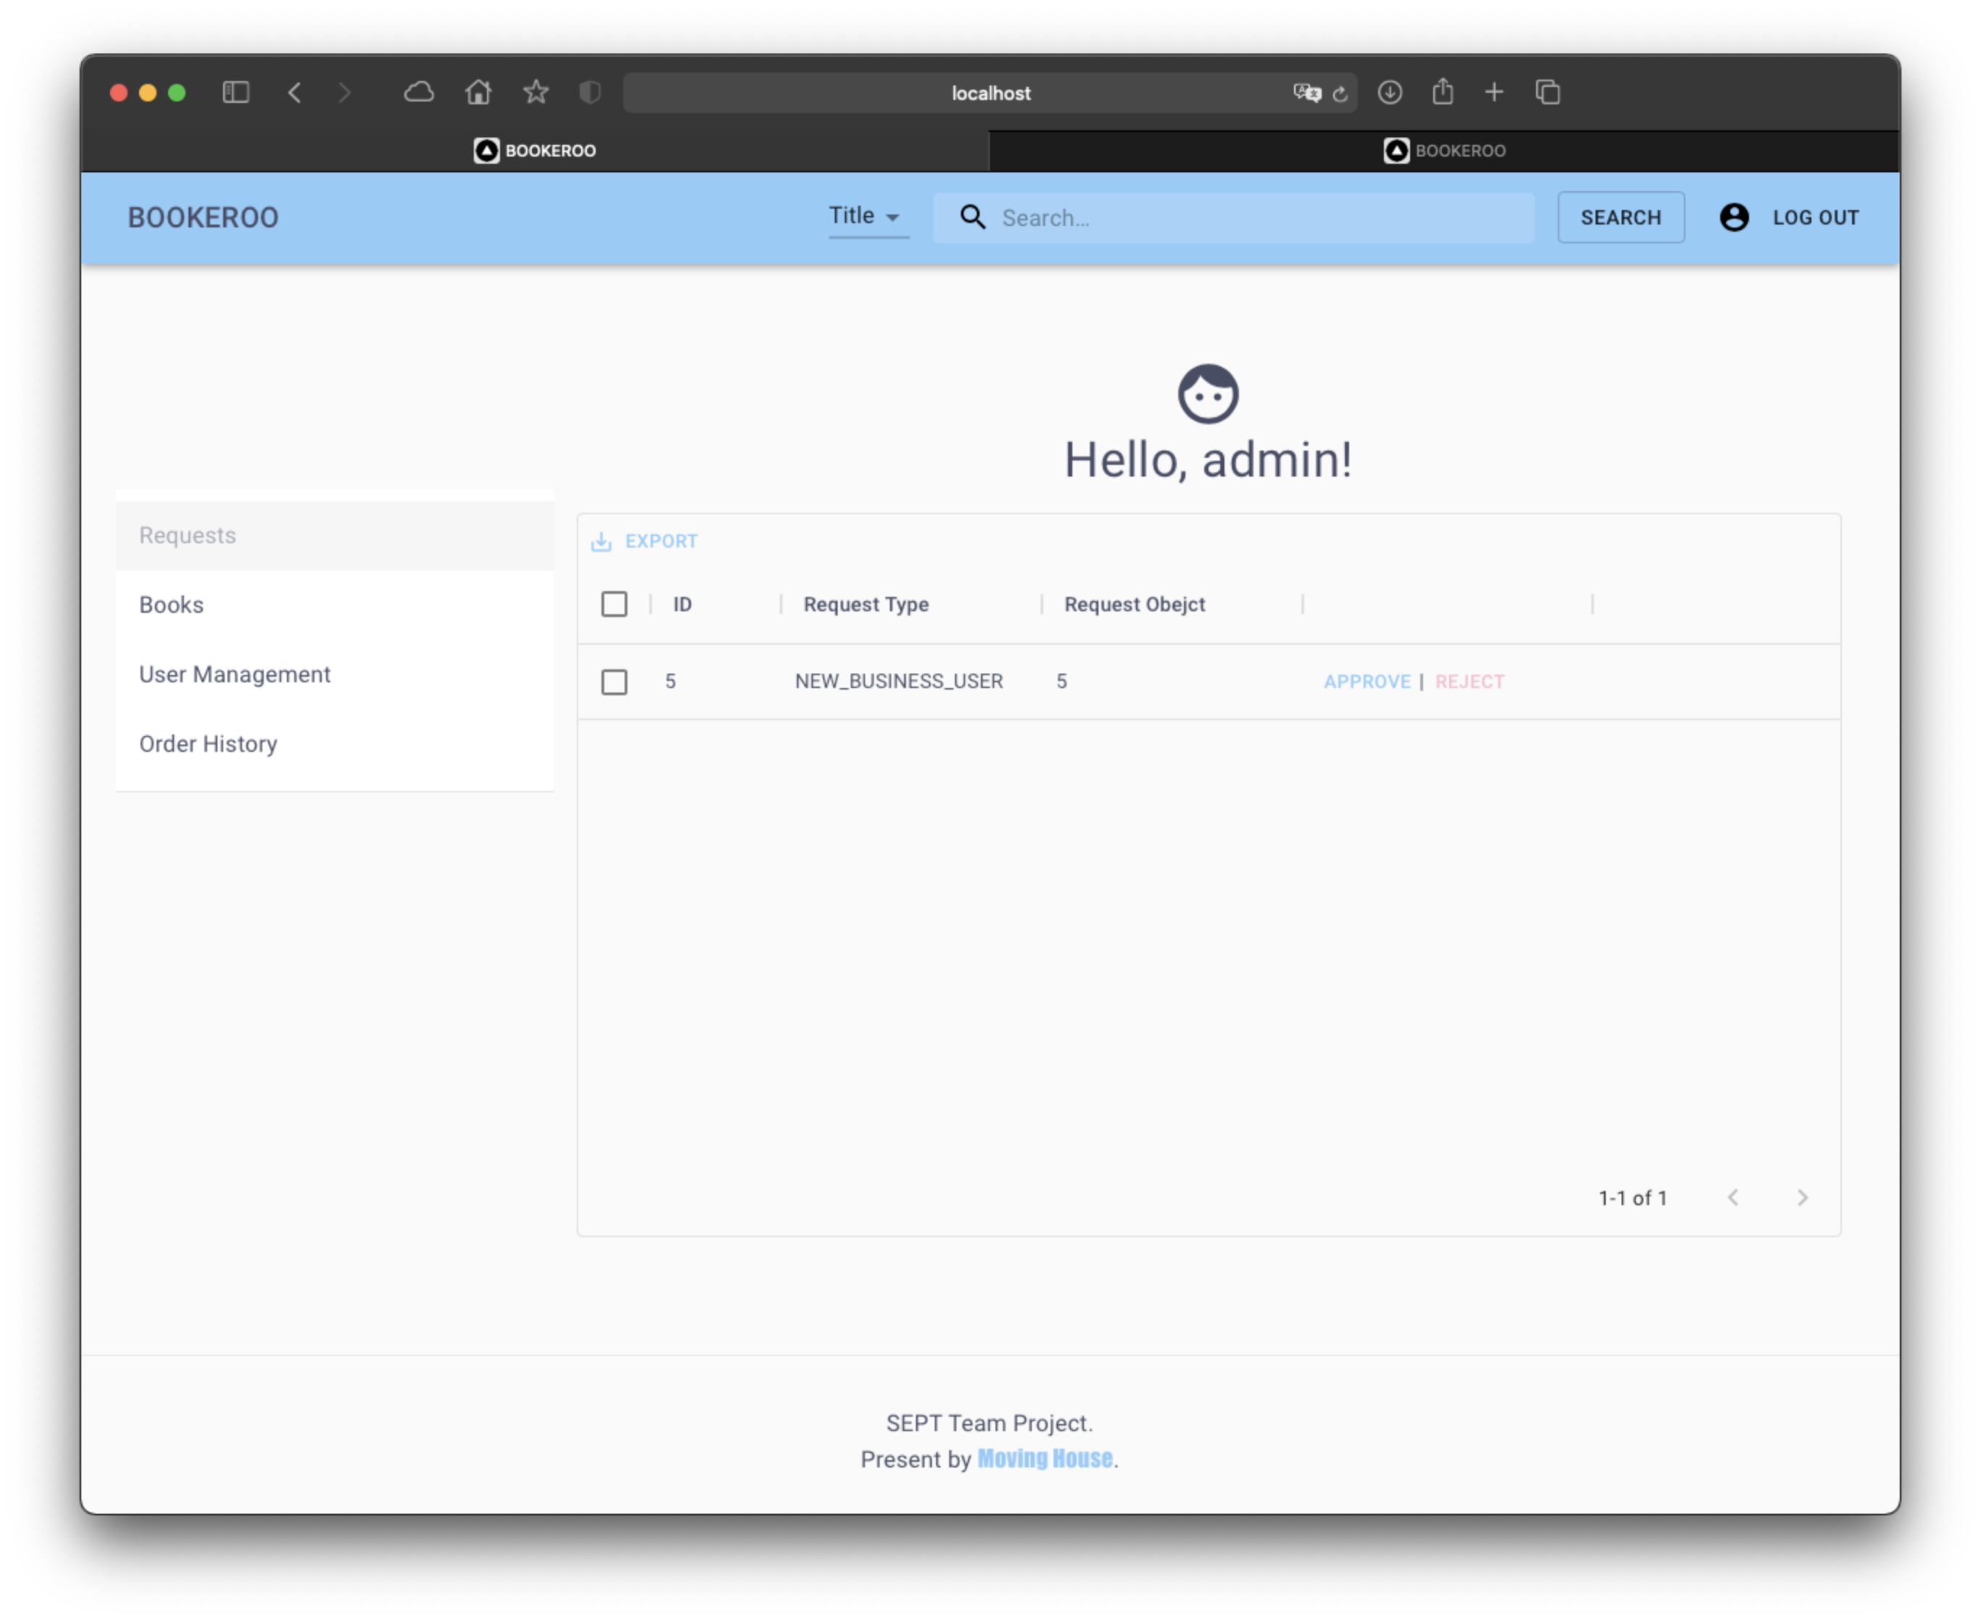

# As an Admin, I want to reject books to be sold by customers, so that fake or invalid books are not listed for selling

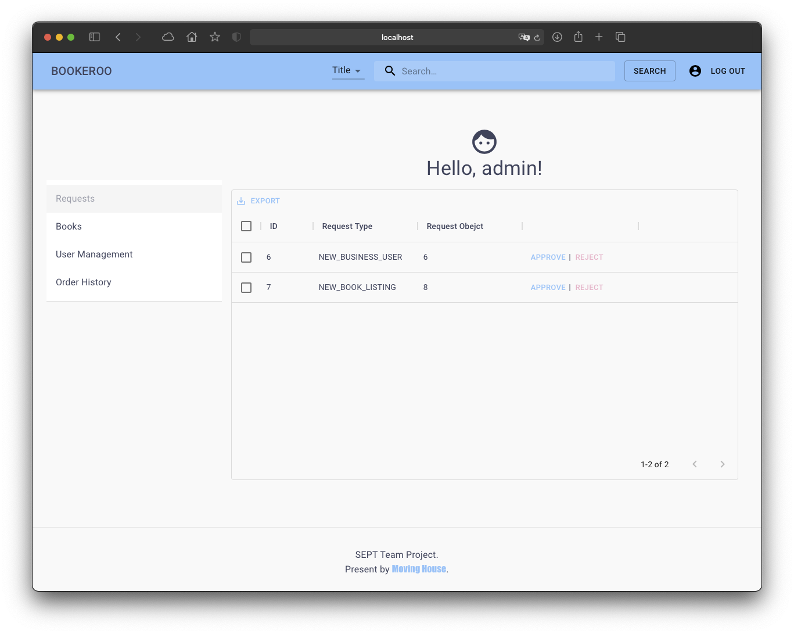

# As an Admin, I want to be able to download reports about books in CSV format, so that I can review what books are available on the website

By clicking the export button, admin will be able to download the book table as csv

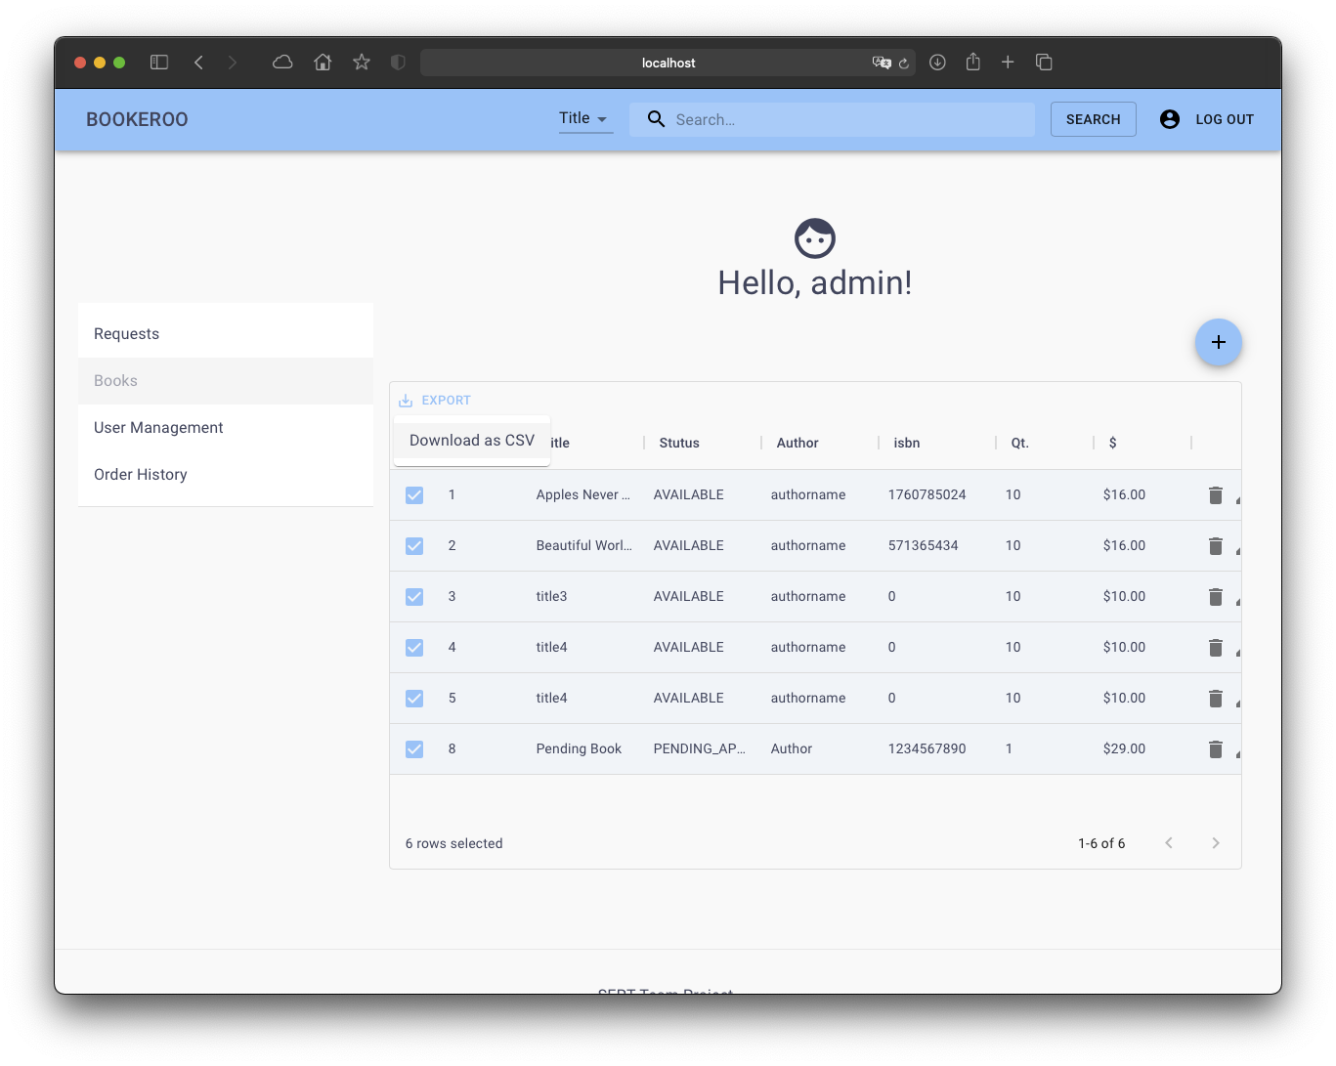

# As an Admin, I want an option to choose how the CSV files are sorted, so I can see what the most popular item is.

For each exportable table could be sorted by each column.

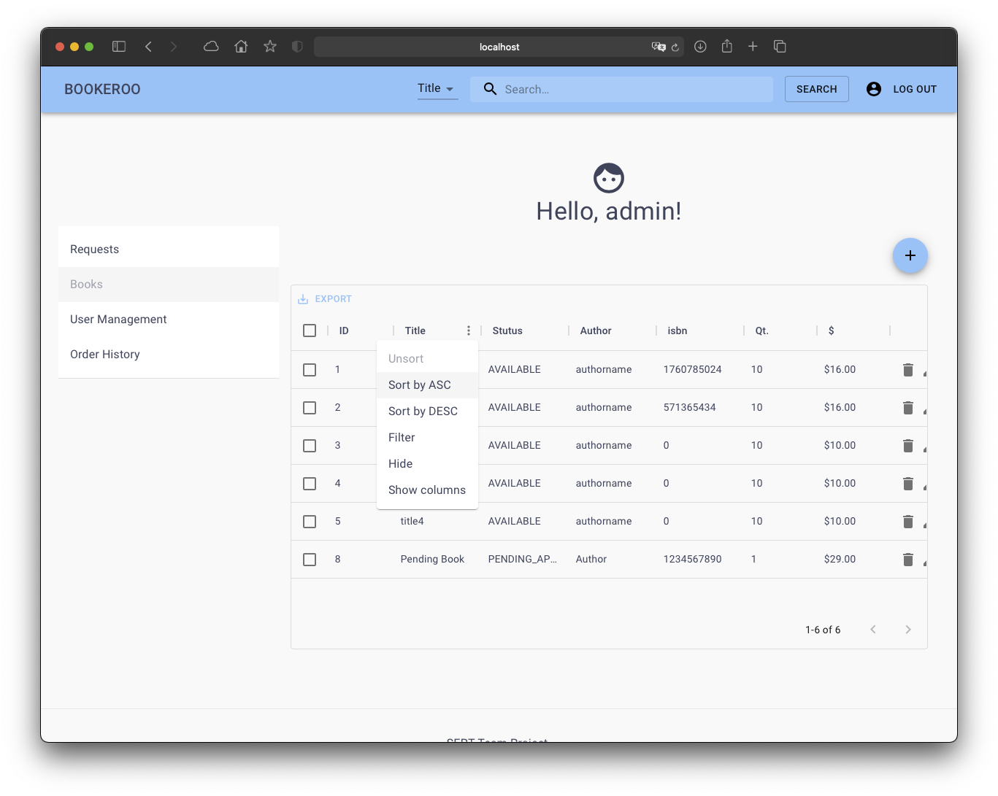

# As a Admin, I want to be able to download reports about user transactions in CSV format, so that I can review the sales history of the website

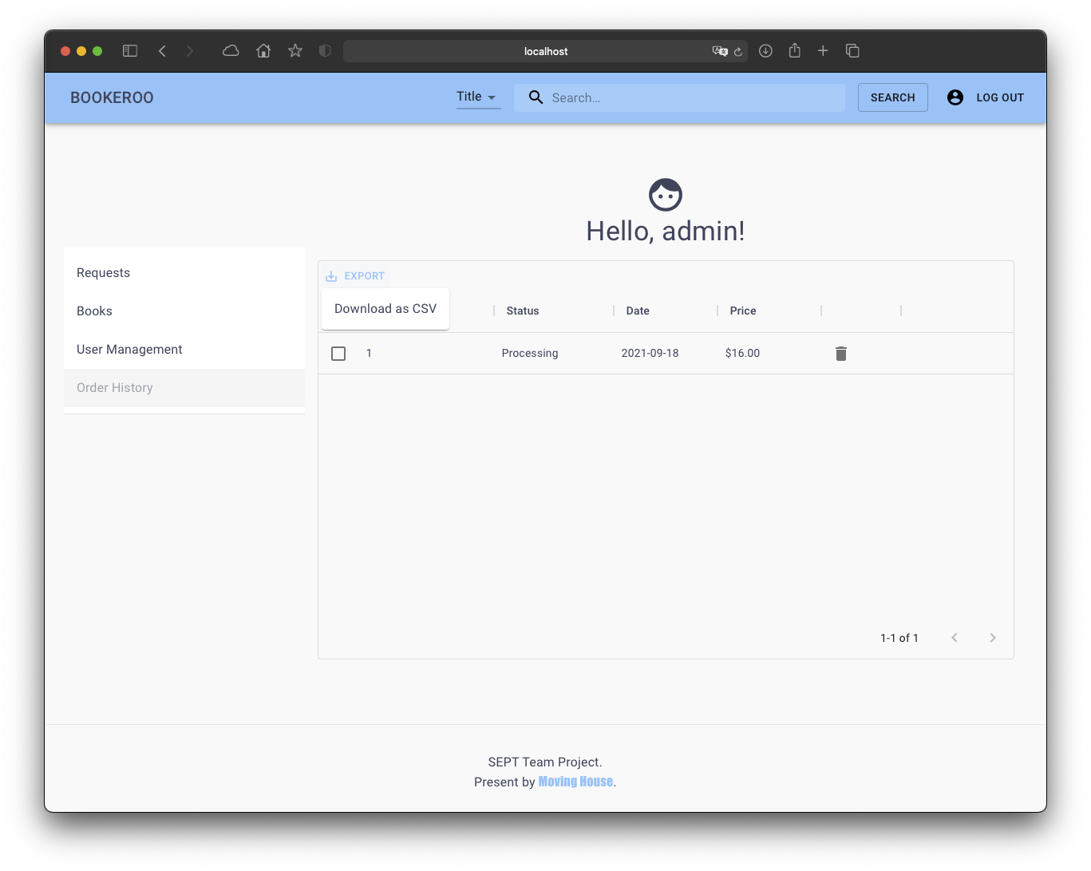

# As an Admin, I want to add new books, so that new items can be sold.

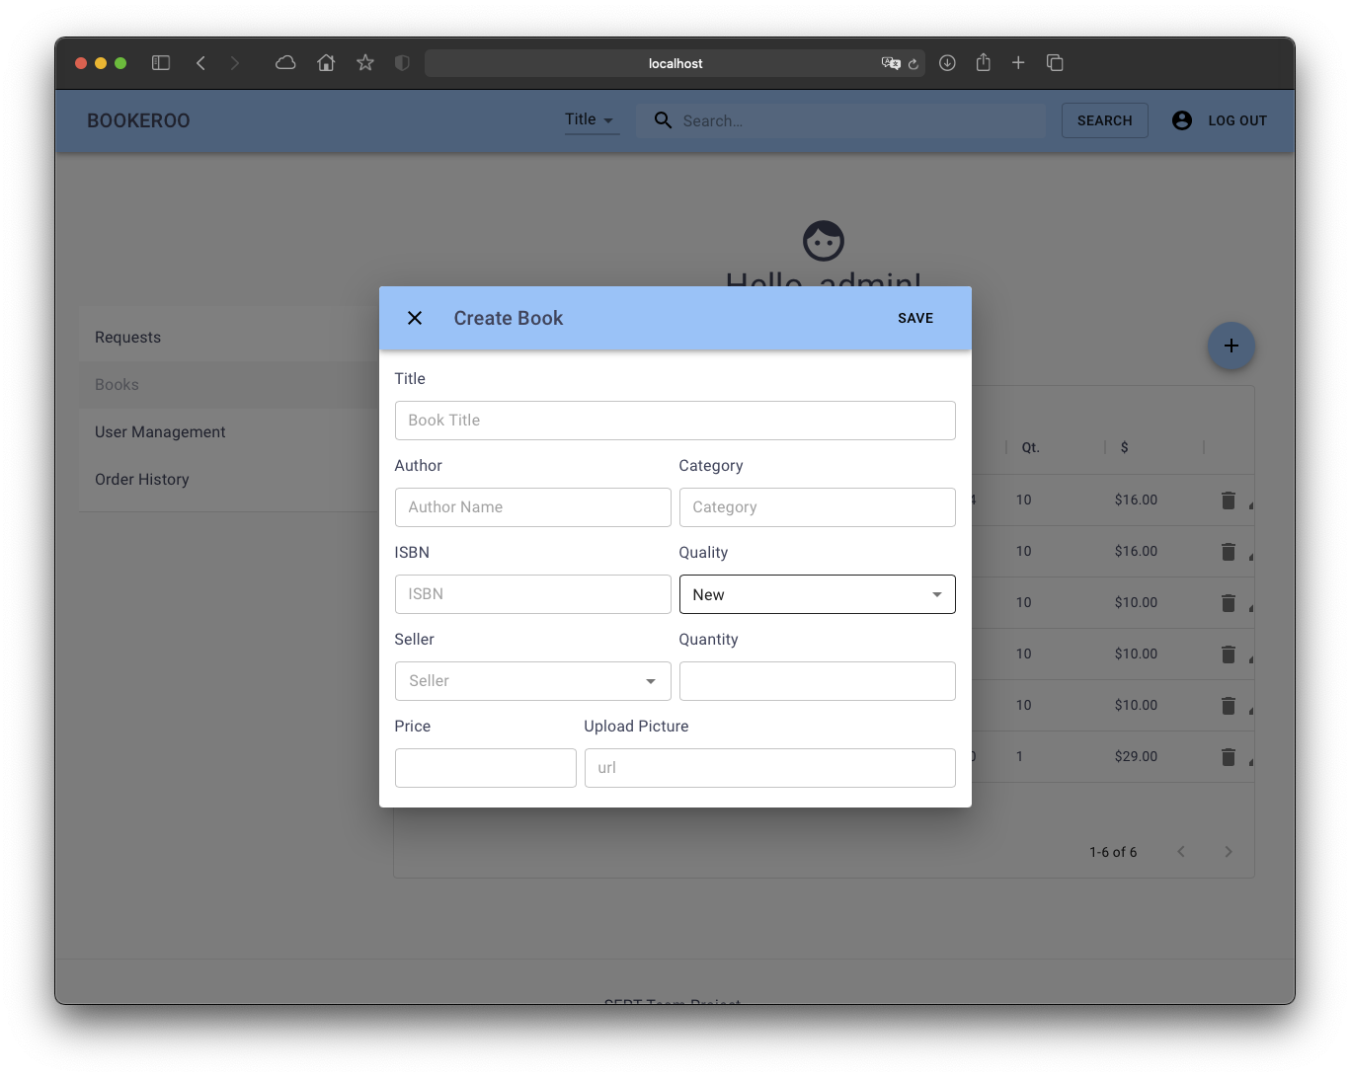

# As an admin, I want to reject a pending registration from a business user so that they are unable to open a new business account.

Admin could reject the business account request by clicking the reject button after each request

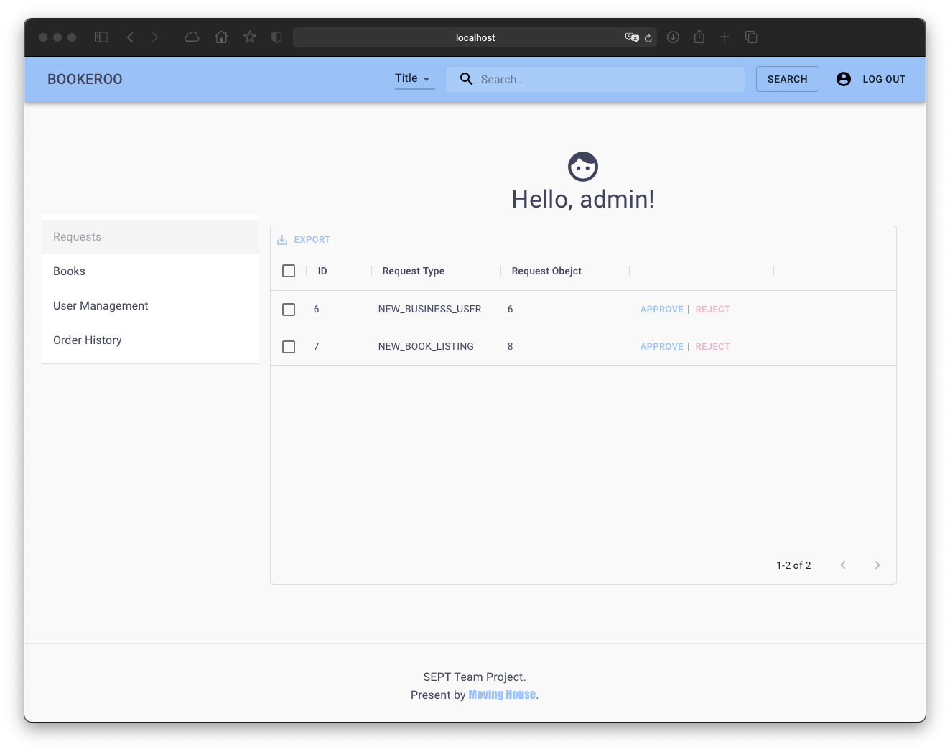

# As an Admin, I want to be able to add stock for a book, so that sellers can add stock to any books in their inventory.

In the edit book page, admin will be able change the number of quantities

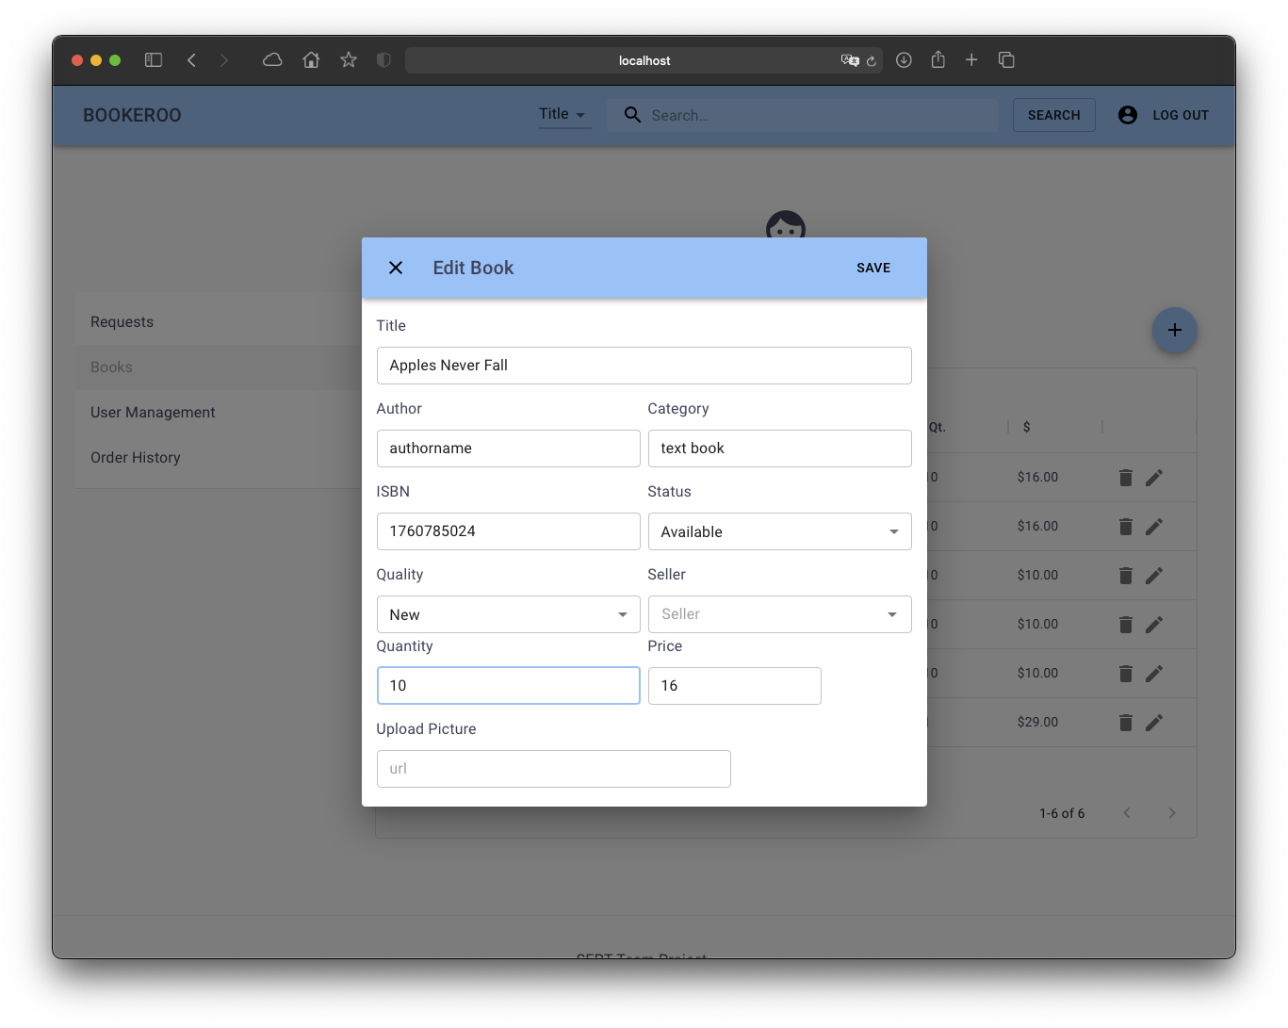

# As an Admin, I want to modify users, so that I can suspend/unsuspend users from their account.

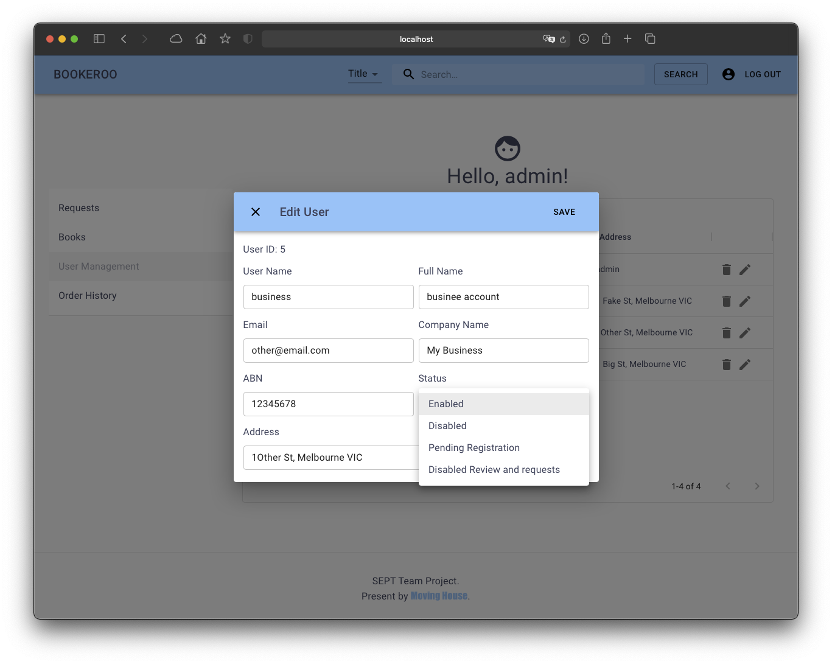

# As a business user, I want to export a CSV of transactions, so I know if the business is making a profit

Similar to an admin account, business user will able to download the transaction history of the book they sold.

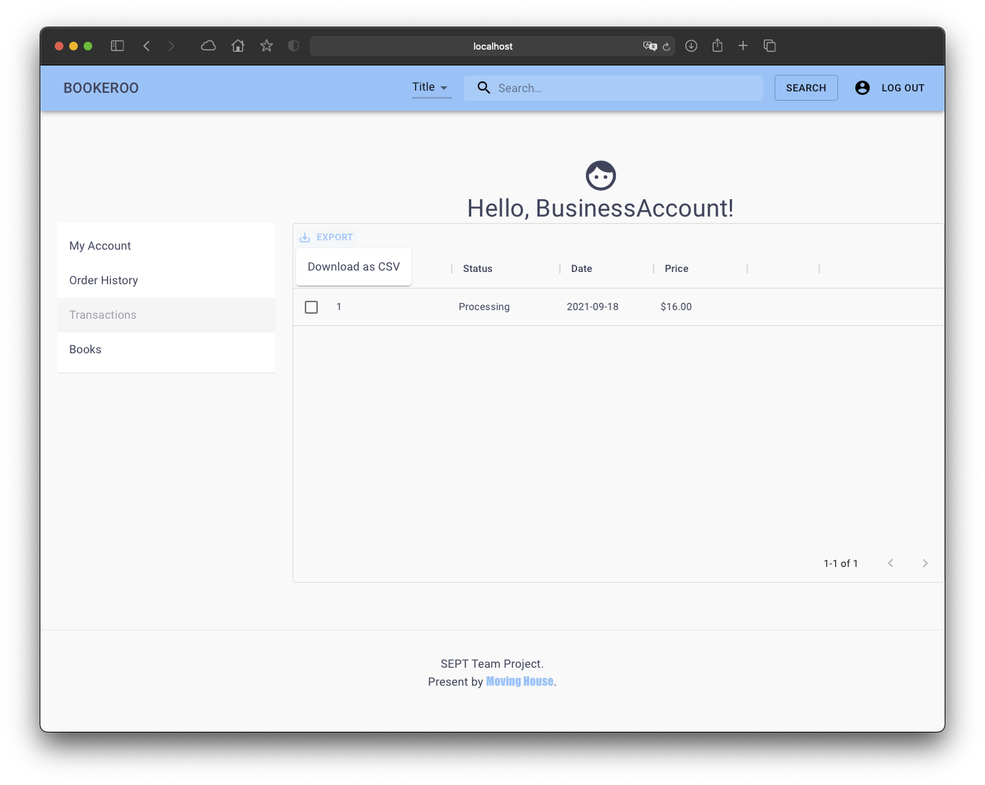

# As a business user, I want to be able to upload an item to sell, so that an admin can approve it.

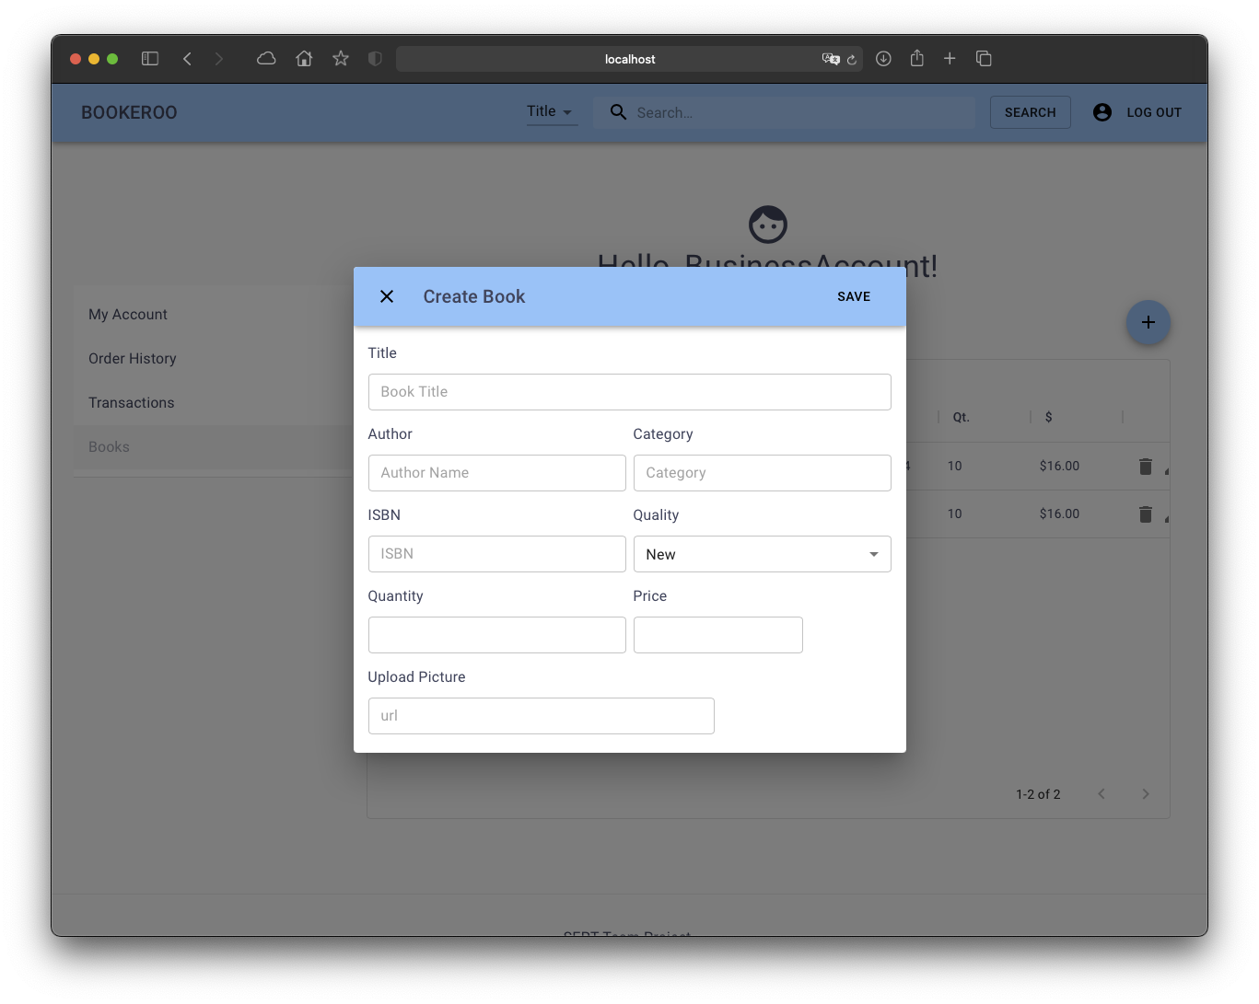

# As a business user, I want to be able to register a business account so that I can sell and rent my books to customers.

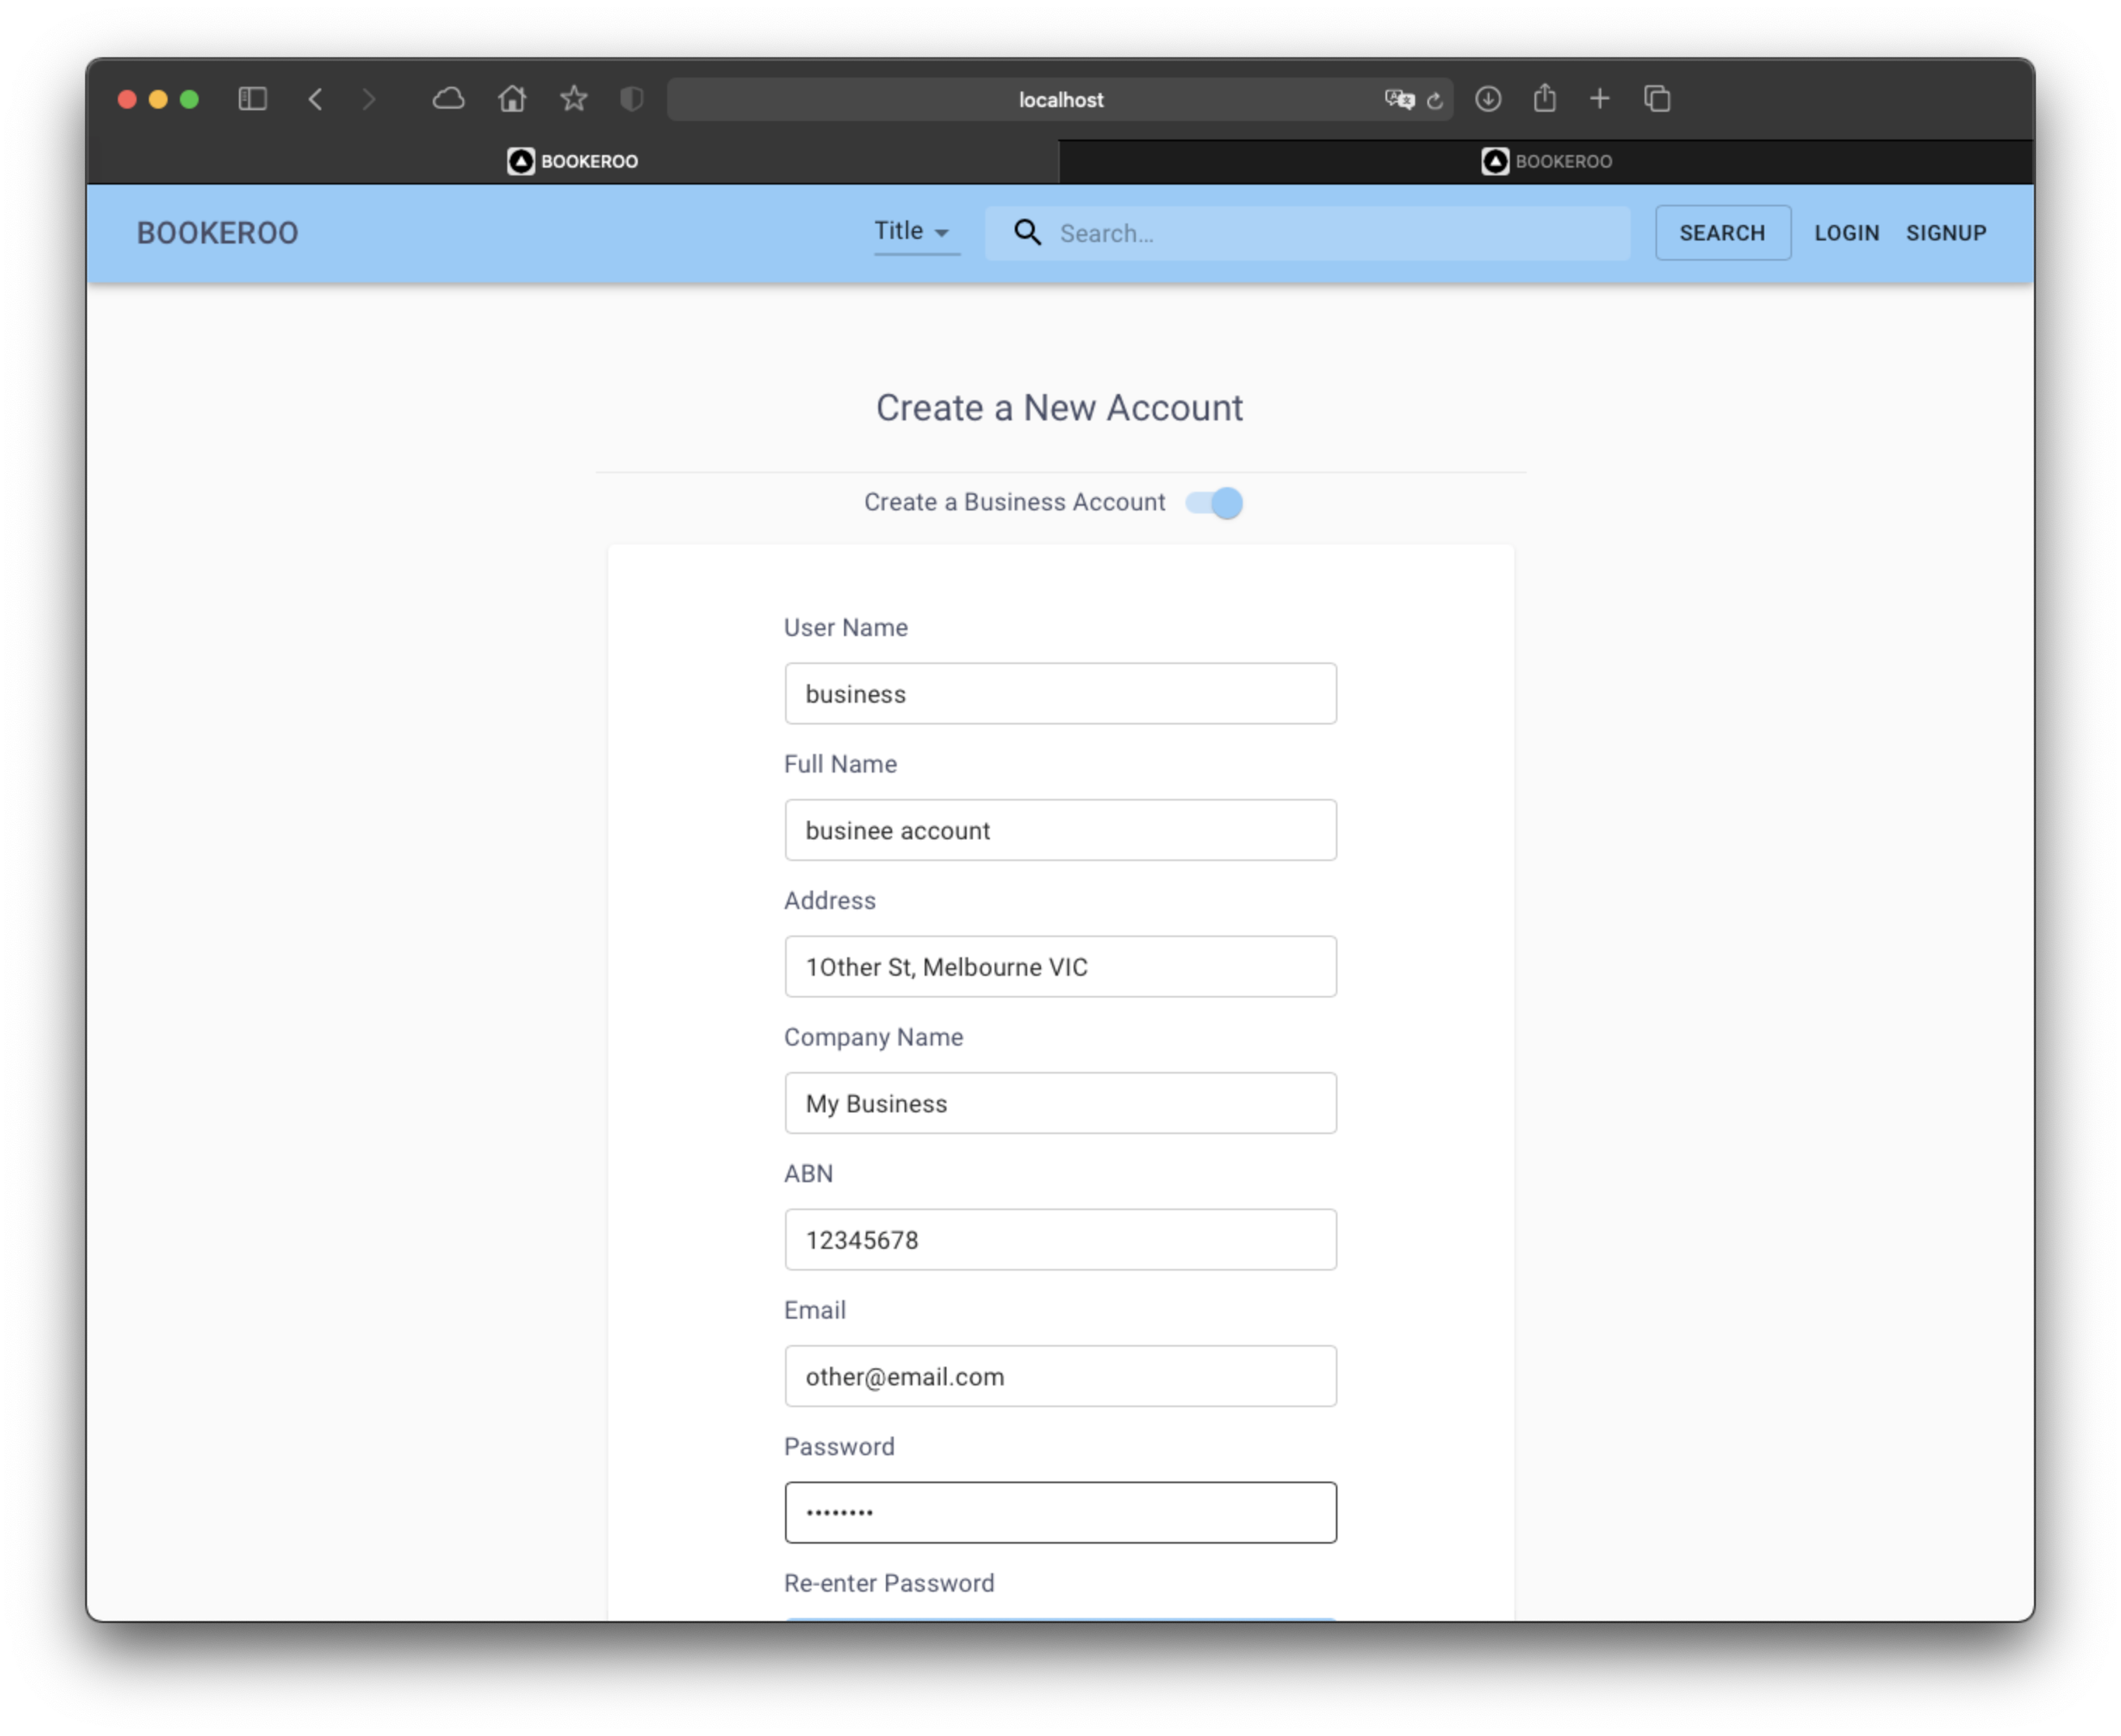

# As a business user, I want to be able to see all previous transactions, so I know how often transactions are happening.

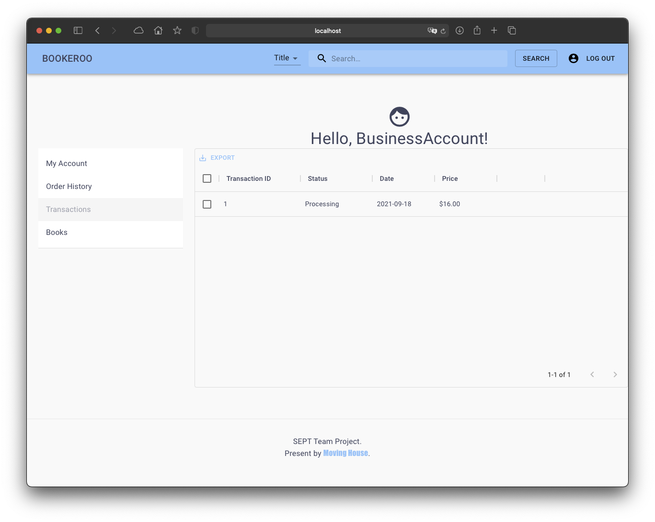

# As a business user, I want to be able to edit the books I am managing, so I can fix mistakes when originally created the book page.

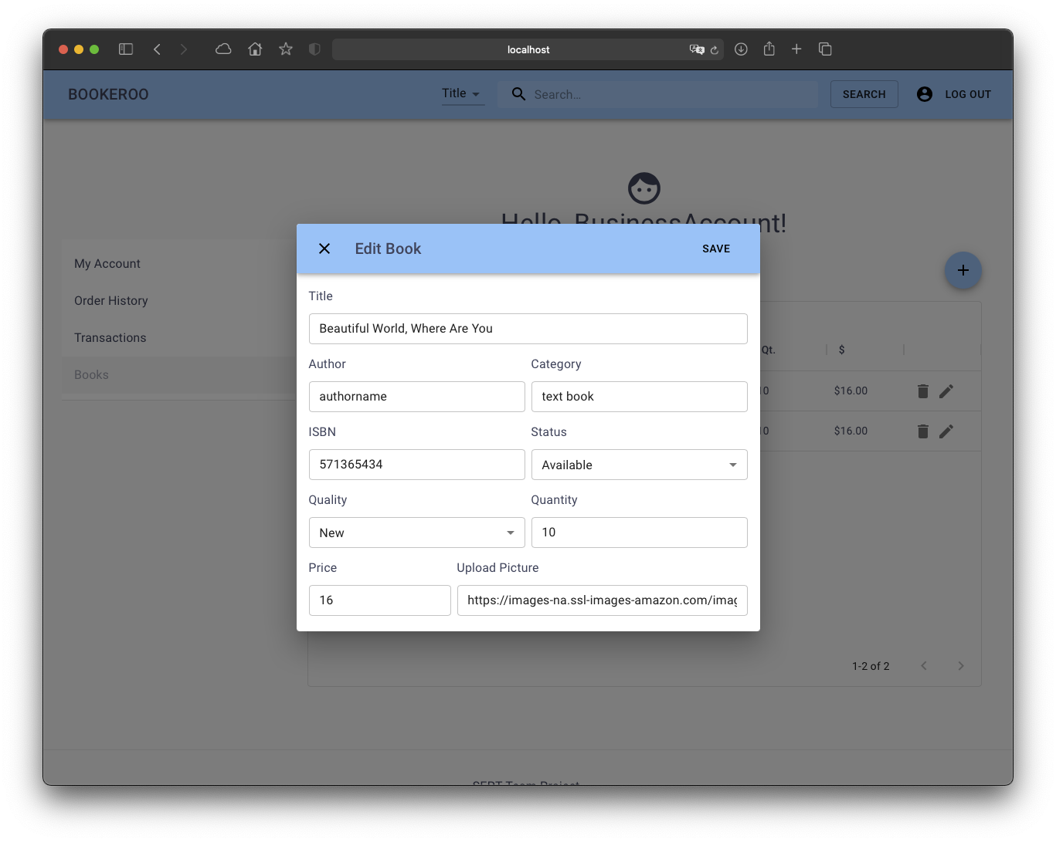

# As a customer, I want to view my profile page so I can change my password

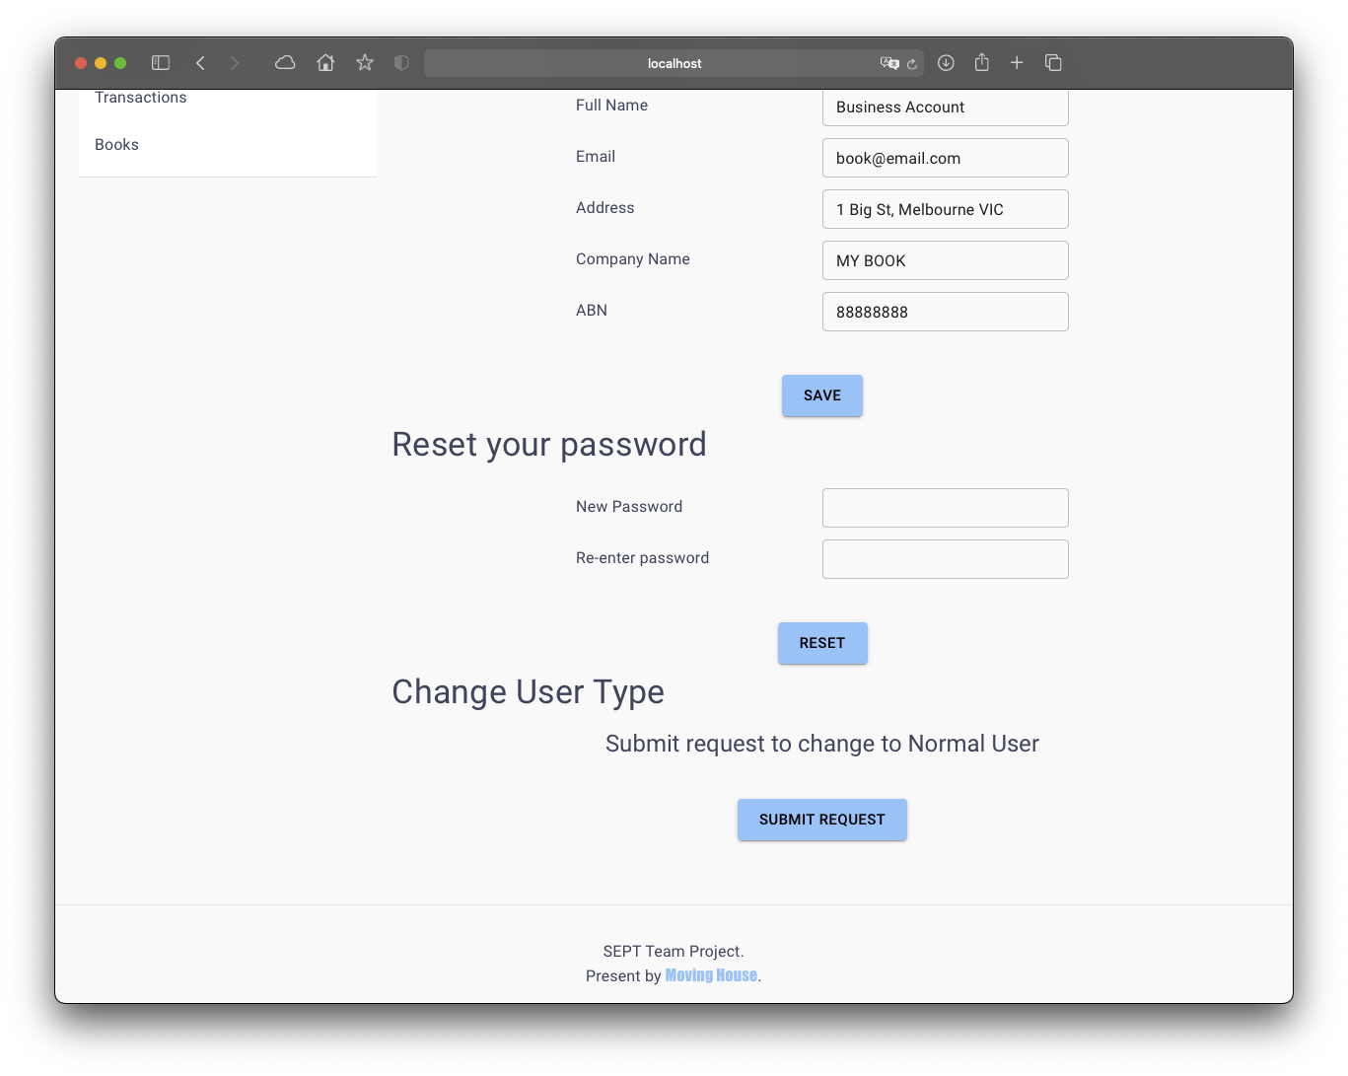

# As a customer, I want to be able to sort my search results so that my search query starts from the lowest cost item.

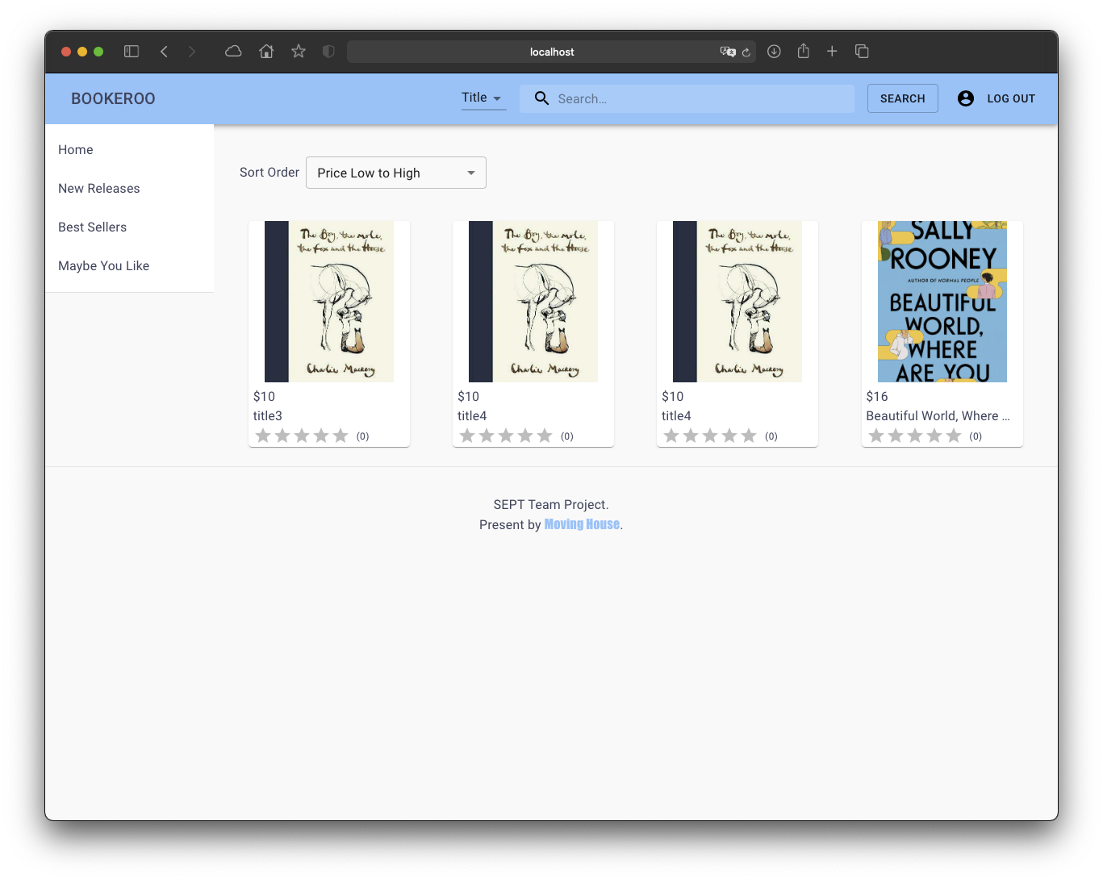

# As a customer, I want to be able to sort my search results so that my search query is ordered alphabetically.

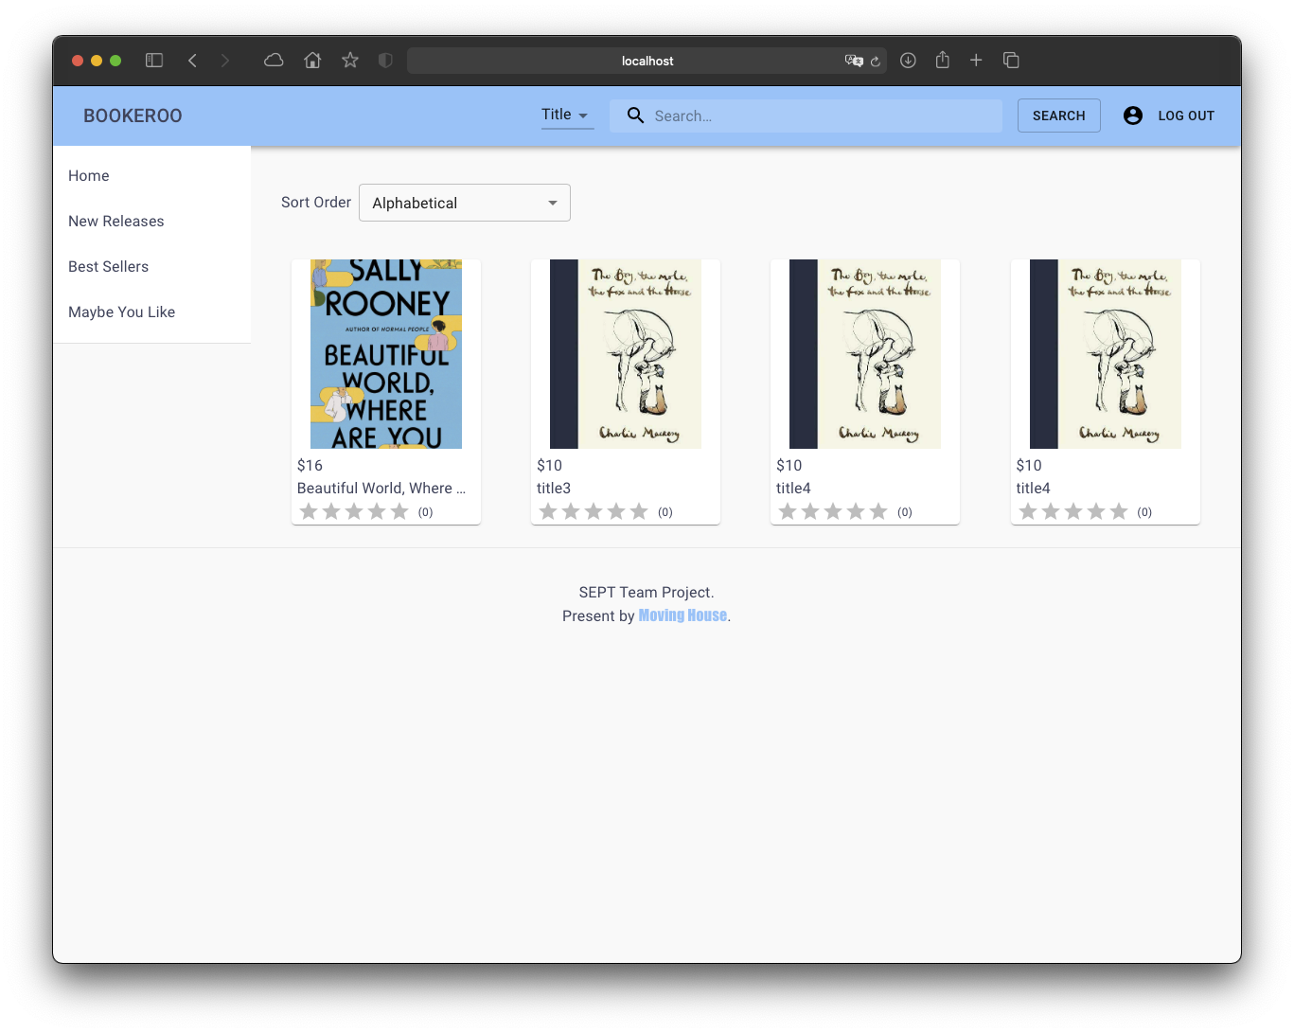

# As a Customer, I want to be able to view my order status, so that I can see the current status of my order.

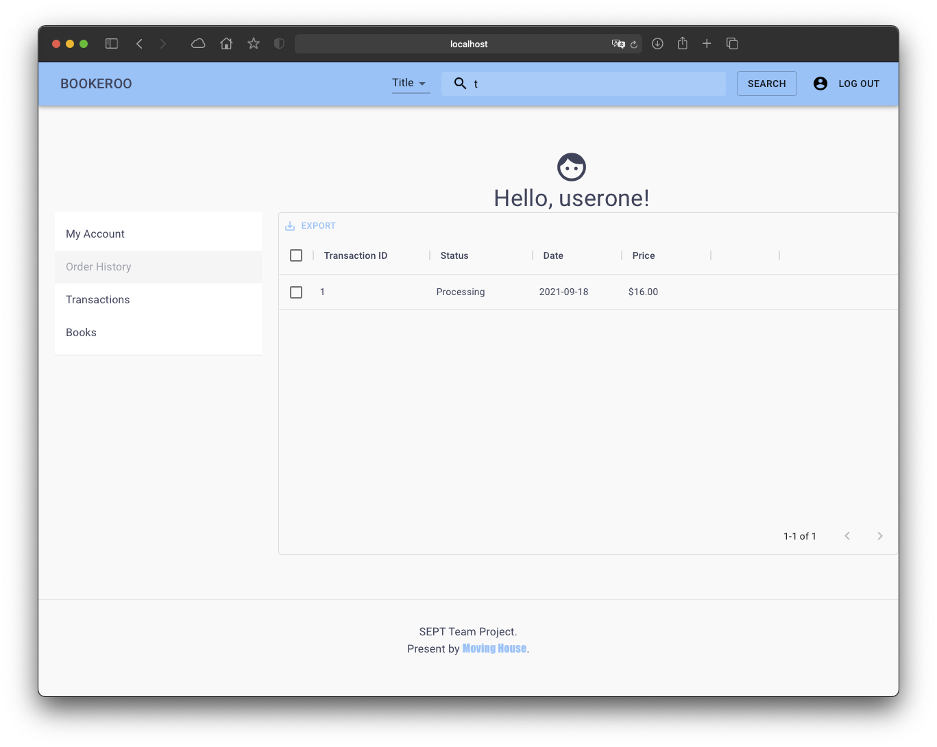

# As a customer, I want to be able to search for books in the catalog by the category of the book so that I can find books with a specific category

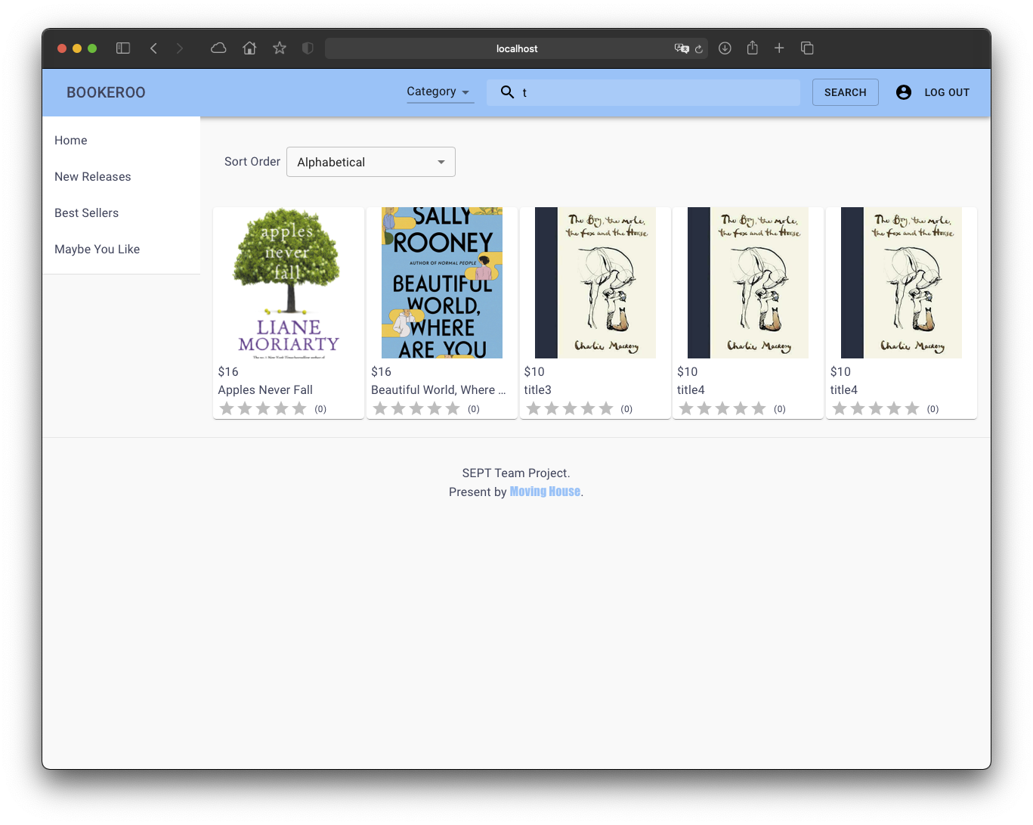

# As a customer, I want to be able to search for books in the catalog by the name of the author so that I can find books written by a specific author

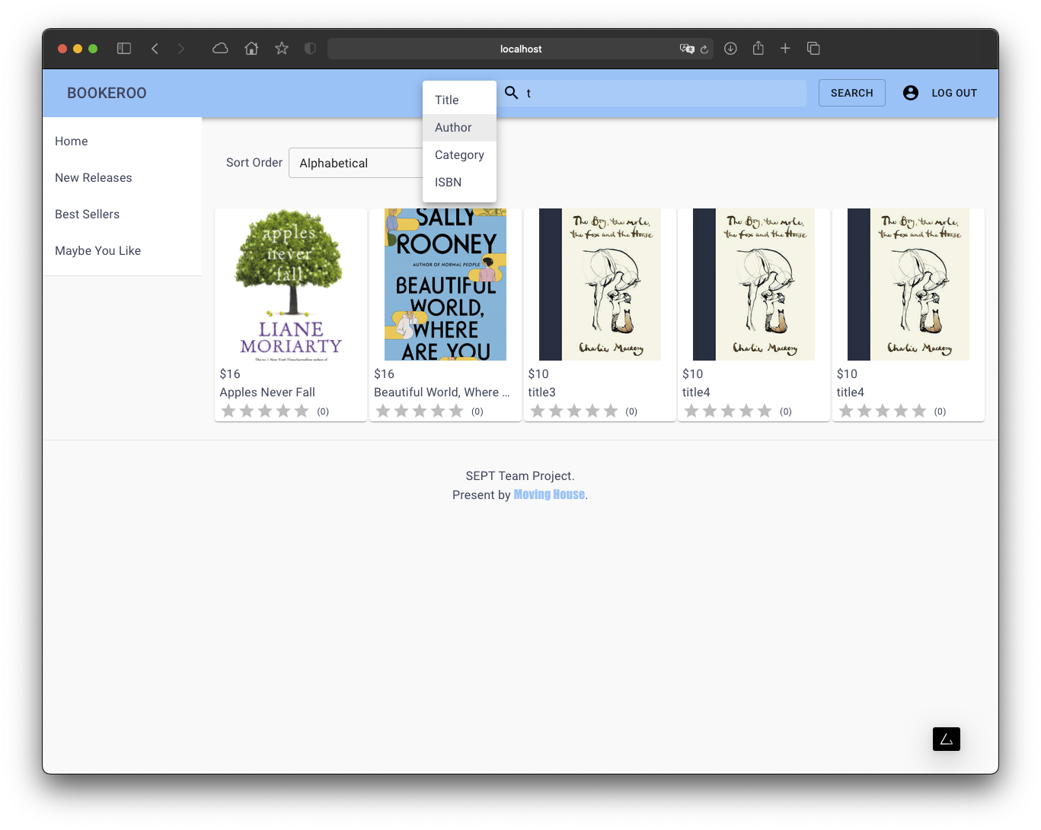

# As a customer, I want to be able to search for books in the catalog by the title of the book so that I can find books with a specific title or series title

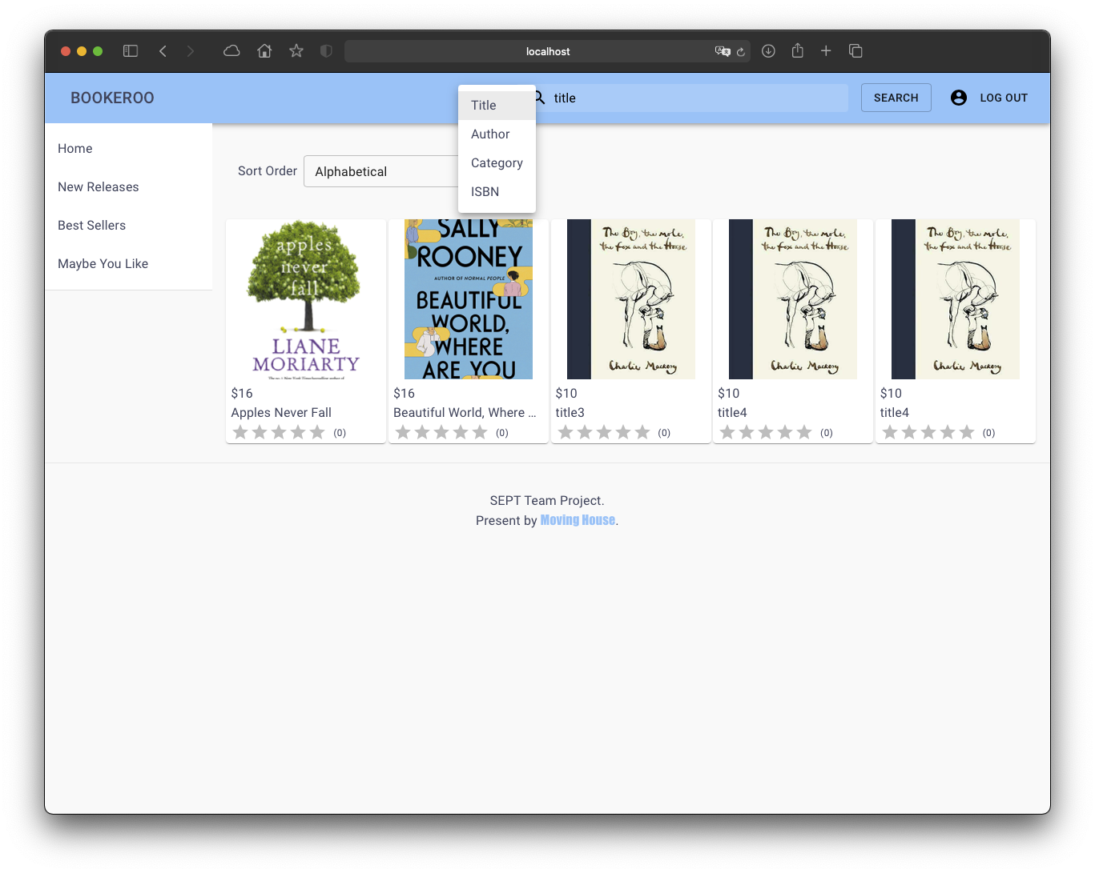

# As a customer, I want to be able to search for books in the catalog by the book's ISBN so that I can find books with a specific ISBN

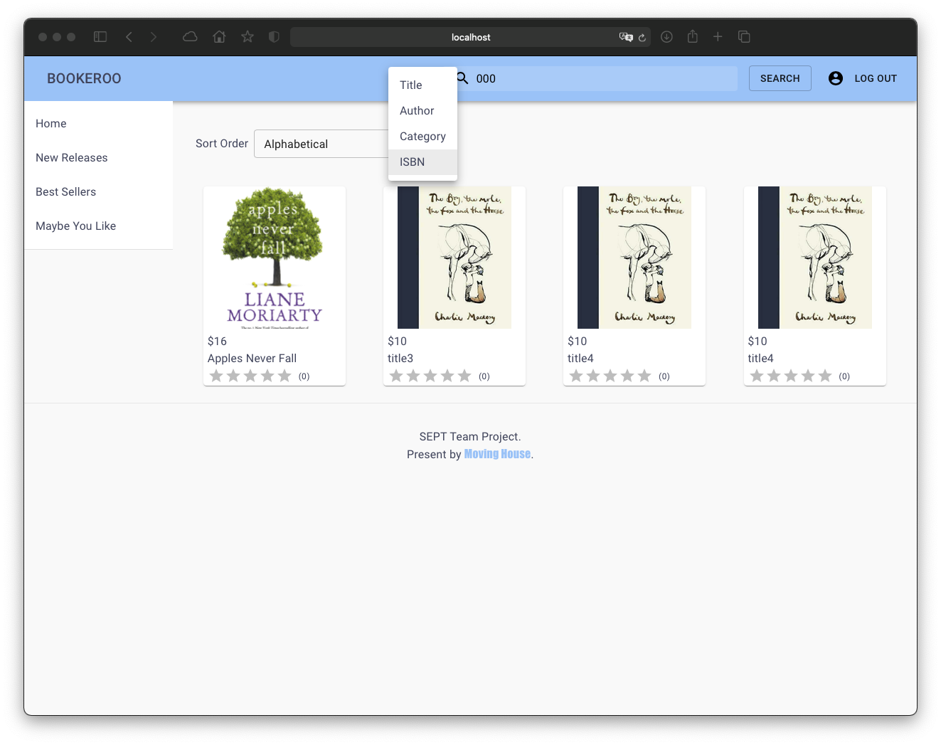

# As a Customer, I want to be able to view my transaction history, so that I can see all my recently bought books

